CHAPTER 2

A REVIEW OF BASIC STATISTICAL CONCEPTS

ANSWERS TO PROBLEMS AND CASES

1. Descriptive Statistics

Variable N Mean Median StDev SE Mean
Orders 28 21.32 17.00 13.37 2.53

Variable Min Max Q1 Q3

Orders 5.00 54.00 11.25 28.75

a. $\bar{X}$ = 21.32
b. S = 13.37
c. S² = 178.76
d. If the policy is successful, smaller orders will be eliminated and the mean will
increase.

- If the change causes all customers to consolidate a number of small orders into
large orders, the standard deviation will probably decrease. Otherwise, it is very
difficult to tell how the standard deviation will be affected.

f. The best forecast over the long-term is the mean of 21.32.

2. Descriptive Statistics

Variable N Mean Median StDev SE Mean
Prices 12 176654 180000 39440 11385

Variable Min Max Q1 Q3
Prices 121450 253000 138325 205625

$\bar{X}$ = 176,654 and S = 39,440

3. a. Point estimate: $\bar{X}=\text{10}\text{.}\text{76}\text{\%}$

b. 1−α = .95 ⇒ Z = 1.96, n = 30, $\bar{X}=\text{10}\text{.}\text{76}, S=\text{13}\text{.}\text{71}$
$\bar{X}±1\text{.}\text{96}\left(S/{\sqrt{n}}\right)=\text{10}\text{.}\text{76}±1\text{.}\text{96}\left(\text{13}\text{.}{\text{71}}/{\sqrt{\text{30}}}\right)=\text{10}\text{.}\text{76}±4\text{.}\text{91}$
(5.85%, 15.67%)

c. df = 30−1 = 29, t = 2.045
$\bar{X}±2\text{.}\text{045}\left(S/{\sqrt{n}}\right)=\text{10}\text{.}\text{76}±2\text{.}\text{045}\left(\text{13}\text{.}{\text{71}}/{\sqrt{\text{30}}}\right)=\text{10}\text{.}\text{76}±5\text{.}\text{12}$
(5.64%, 15.88%)

- We see that the 95% confidence intervals in b and c are not much different because the multipliers 1.96 and 2.045 are nearly the same magnitude.
This explains why a sample of size n = 30 is often taken as the cutoff between
large and small samples.

4. a. Point estimate: $\bar{X}=\frac{\text{23}\text{.}\text{41}+\text{102}\text{.}\text{59}}{2}=\text{63}$
95% error margin: (102.59 − 23.41)/2 = 39.59

b. 1−α = .90 ⇒ Z = 1.645, $\bar{X}=\text{63}, S/{\sqrt{n}}=\text{39}\text{.}{\text{59}}/1\text{.}\text{96}=\text{20}\text{.}2$
$\bar{X}±1\text{.}\text{645}\left(S/{\sqrt{n}}\right)=\text{63}±1\text{.}\text{645}(\text{20}\text{.}2)=\text{63}±\text{33}\text{.}\text{23}$
(29.77, 96.23)

5. H₀: μ = 12.1 n = 100 α = .05
H₁: μ > 12.1 S = 1.7 $\bar{X}$ = 13.5

Reject H₀ if Z > 1.645

Z = $\frac{\text{13}\text{.}5−\text{12}\text{.}1}{1\text{.}7\sqrt{\text{100}}}$= 8.235

Reject H₀ since the computed Z (8.235) is greater than the critical Z (1.645). The mean has increased.

6. point estimate: 8.1 seats
interval estimate: 8.1 ± 1.96 $5\text{.}7\sqrt{\text{49}}$ ⇒ 6.5 to 9.7 seats
Forecast 8.1 empty seats per flight; very likely the mean number of empty seats will lie between 6.5 and 9.7.

7. n = 60, $\bar{X}=5\text{.}\text{60}, S=\text{.}\text{87}$
$\begin{aligned}H_{0}:μ=5\text{.}9 \\ H_{1}:μ≠5\text{.}9\end{aligned}$ two-sided test, α = .05, critical value: |Z|= 1.96
Test statistic: $Z=\frac{\bar{X}−5\text{.}9}{S/{\sqrt{n}}}=\frac{5\text{.}\text{60}−5\text{.}9}{\text{.}{\text{87}}/{\sqrt{\text{60}}}}=−2\text{.}\text{67}$

Since |−2.67| = 2.67 > 1.96, reject $H_{0}$ at the 5% level. The mean satisfaction rating is
different from 5.9.
p-value: P(Z < − 2.67 or Z > 2.67) = 2 P(Z > 2.67) = 2(.0038) = .0076, very strong
evidence against $H_{0}$.

8. df = n −1 = 14 −1 = 13, $\bar{X}=4\text{.}\text{31}, S=\text{.}\text{52}$
$\begin{aligned}H_{0}:μ=4 \\ H_{1}:μ>4\end{aligned}$ one-sided test, α = .05, critical value: t = 1.771
Test statistic: $t=\frac{\bar{X}−4}{S/{\sqrt{n}}}=\frac{4\text{.}\text{31}−4}{\text{.}{\text{52}}/{\sqrt{\text{14}}}}=2\text{.}\text{23}$

Since 2.23 > 1.771, reject $H_{0}$ at the 5% level. The medium-size serving contains an
average of more than 4 ounces of yogurt.

p-value: P(t > 2.23) = .022, strong evidence against $H_{0}$

9. H₀: μ = 700 n = 50 α = .05
H₁: μ ≠ 700 S = 50 $\bar{X}$ = 715

Reject H₀ if Z < -1.96 or Z > 1.96

Z = $\frac{\text{715}−\text{700}}{\text{50}\sqrt{\text{50}}}$ = 2.12

Since the calculated Z is greater than the critical Z (2.12 > 1.96), reject the null hypothesis. The forecast does not appear to be reasonable.

p-value: P(Z < − 2.12 or Z > 2.12) = 2 P(Z > 2.12) = 2(.017) = .034, strong evidence
against $H_{0}$

10. This problem can be used to illustrate how a random sample is selected with Minitab. In
order to generate 30 random numbers from a population of 200 click the following menus:

Calc>Random Data>Integer

The Integer Distribution dialog box shown in the figure below appears. The number of random digits desired, 30, is entered in the Number of rows of data to generate space. C1 is entered for Store in column(s) and 1 and 200 are entered as the Minimum and Maximum values. OK is clicked and the 30 random numbers appear in Column 1 of the worksheet.

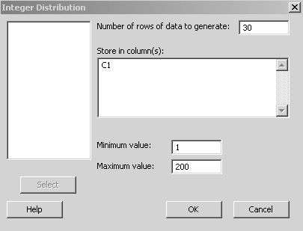

The null hypothesis that the mean is still 2.9 is true since the actual mean of the population of data is 2.91 with a standard deviation of 1.608; however, a few students may reject the null hypothesis, committing a Type I error.

11. a.
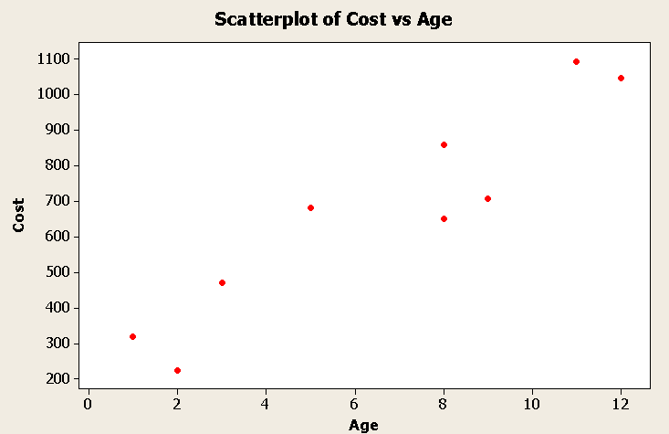

b. Positive linear relationship

c. ∑Y = 6058 ∑Y² = 4,799,724 ∑X = 59
∑X² = 513 ∑XY = 48,665 r = .938

12. a.

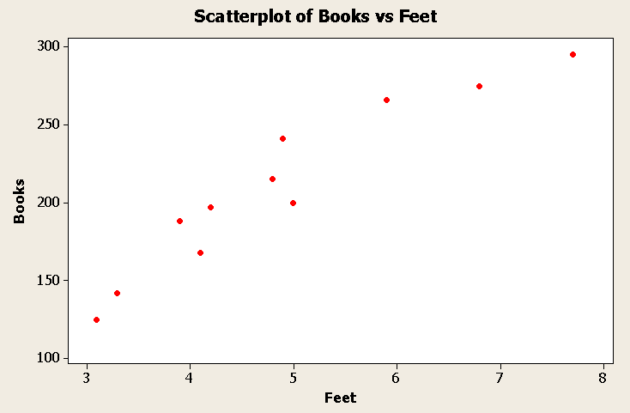

b. Positive linear relationship

c. ∑Y = 2312 ∑Y2 = 515,878 ∑X = 53.7
∑X2 = 282.55 ∑XY = 12,029.3 r = .95

$\hat{Y}$ = 32.5 + 36.4X
$\hat{Y}$ = 32.5 + 36.4(5.2) = 222

13. This is a good population for showing how random samples are taken. If three-digit random numbers are generated from Minitab as demonstrated in Problem 10, the selected items for the sample can be easily found. In this population, ρ = 0.06 so most
students will get a sample correlation coefficient r close to 0. The least squares line will, in
most cases, have a slope coefficient close to 0, and students will not be able to reject the
null hypothesis H₀: β₁ = 0 (or, equivalently, ρ = 0) if they carry out the hypothesis test.

14. a.

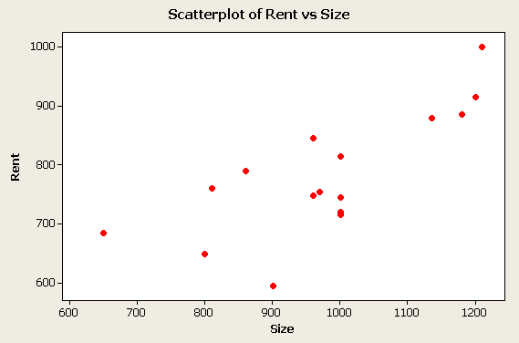

b. Rent = 275.5 + .518 Size

- Slope coefficient = .518 ⇒ Increase of $.518/month for each additional square
foot of space.

d. Size = 750 ⇒ Rent = 275.5 + .518(750) = $664/month

15. n = 175, $\bar{X}=\text{45}\text{.}2, S=\text{10}\text{.}3$
Point estimate: $\bar{X}=\text{45}\text{.}2$
98% confidence interval: 1−α = .98 ⇒ Z = 2.33
$\bar{X}±2\text{.}\text{33}\left(S/{\sqrt{n}}\right)=\text{45}\text{.}2±2\text{.}\text{33}\left(\text{10}\text{.}3/{\sqrt{\text{175}}}\right)=\text{45}\text{.}2±1\text{.}8$ ⇒ (43.4, 47.0)

Hypothesis test:
$\begin{aligned}H_{0}:μ=\text{44} \\ H_{1}:μ≠\text{44}\end{aligned}$ two-sided test, α = .02, critical value: |Z|= 2.33
Test statistic: $Z=\frac{\bar{X}−\text{44}}{S/{\sqrt{n}}}=\frac{\text{45}\text{.}2−\text{44}}{\text{10}\text{.}3/{\sqrt{\text{175}}}}=1\text{.}\text{54}$

Since |Z| = 1.54 < 2.33, do not reject $H_{0}$ at the 2% level.

As expected, the results of the hypothesis test are consistent with the confidence
interval for μ; μ = 44 is not ruled out by either procedure.
16. a. $\begin{aligned}H_{0}:μ=\text{63},\text{700} \\ H_{1}:μ>\text{63},\text{700}\end{aligned}$

b. $\begin{aligned}H_{0}:μ=4\text{.}3 \\ H_{1}:μ≠4\text{.}3\end{aligned}$

c. $\begin{aligned}H_{0}:μ=\text{1300} \\ H_{1}:μ<\text{1300}\end{aligned}$

- Large sample 95% confidence interval for mean monthly return μ:

$−1\text{.}\text{10}±1\text{.}\text{96}\frac{5\text{.}\text{99}}{\sqrt{\text{39}}}=−1\text{.}\text{10}±1\text{.}\text{88} ⇒ (−2\text{.}\text{98}, \text{.}\text{78})$

μ = .94 (%) is not a realistic value for mean monthly return of client’s
account since it falls outside the 95% confidence interval. Client may have a
case.

18. a.

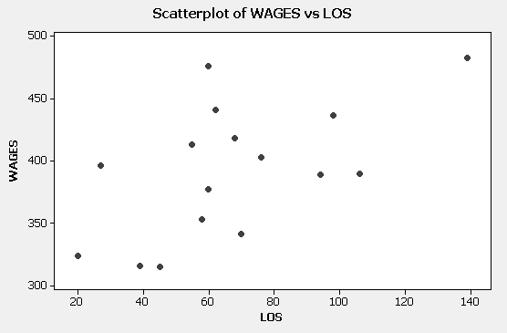

b. r = .581, positive linear association between wages and length of service.
Other variables affecting wages may be size of bank and previous experience.

c. WAGES = 324.3 + 1.006 LOS
WAGES = 324.3 + 1.006 (80) = 405

CASE 2-1: ALCAM ELECTRONICS

In our consulting work, business people sometimes tell us that business schools teach a risk-taking attitude that is too conservative. This is often reflected, we are told, in students choosing too low a significance level: such a choice requires extreme evidence to move one from the status quo. This case can be used to generate a discussion on this point as David chooses α = .01 and ends up "accepting" the null hypothesis that the mean lifetime is 5000 hours.

Alice's point is valid: the company may be put in a bad position if it insists on very dramatic evidence before abandoning the notion that its components last 5000 hours. In fact, the indifference α (p-value) is about .0375; at any higher level the null hypothesis of 5000 hours is rejected.

CASE 2-2: MR. TUX

In this case, John Mosby tries some primitive ways of forecasting his monthly sales. The things he tries make some sort of sense, at least for a first cut, given that he has had no formal training in forecasting methods. Students should have no trouble finding flaws in his efforts, such as:
1. The mean value for each year, if projected into the future, is of little value since month-to-month variability is missing.
2. His free-hand method of fitting a regression line through his data can be improved
upon using the least squares method, a technique now found on inexpensive hand calculators. The large standard deviation for his monthly data suggests considerable month-to-month variability and, perhaps, a strong
seasonal effect, a factor not accounted for when the values for a year are averaged.

Both the hand-fit regression line and John's interest in dealing with the monthly seasonal factor suggest techniques to be studied in later chapters. His efforts also point out the value of learning about well-established formal forecasting methods rather than relying on intuition and very simple methods in the absence of knowledge about forecasting. We hope students will begin to appreciate the value of formal forecasting methods after learning about John's initial efforts.

CASE 2-3: ALOMEGA FOOD STORES

Julie’s initial look at her data using regression analysis is a good start. She found that the r-squared value of 36% is not very high. Using more predictor variables, along with examining their significance in the equation, seems like a good next step. The case suggests that other techniques may prove even more valuable, techniques to be discussed in the chapters that follow.

Examining the residuals of her equation might prove useful. About how large are these errors? Are forecast errors in this range acceptable to her? Do the residuals seem to remain in the same range over time, or do they increase over time? Are a string of negative residuals followed by a string of positive residuals or vice versa? These questions involve a deeper understanding of forecasting using historical values and these matters will be discussed more fully in later chapters.

CHAPTER 3

EXPLORING DATA PATTERNS AND
CHOOSING A FORECASTING TECHNIQUE

ANSWERS TO PROBLEMS AND CASES

1. Qualitative forecasting techniques rely on human judgment and intuition. Quantitative
forecasting techniques rely more on manipulation of historical data.

2. A time series consists of data that are collected, recorded, or observed over successive
increments of time.

3. The secular trend of a time series is the long-term component that represents the growth or
decline in the series over an extended period of time. The cyclical component is the wave-
like fluctuation around the trend. The seasonal component is a pattern of change that
repeats itself year after year. The irregular component is that part of the time
series remaining after the other components have been removed.

4. Autocorrelation is the correlation between a variable, lagged one or more period, and itself.

5. The autocorrelation coefficient measures the correlation between a variable, lagged one or
more periods, and itself.

6. The correlogram is a useful graphical tool for displaying the autocorrelations for various
lags of a time series. Typically, the time lags are shown on a horizontal scale and the
autocorrelation coefficients, the correlations between Yt and Yt-k, are displayed as vertical
bars at the appropriate time lags. The lengths and directions (from 0) of the bars indicate
the magnitude and sign of the of the autocorrelation coefficients. The lags at which
significant autocorrelations occur provide information about the nature of the time series.

7. a. nonstationary series
b. stationary series
c. nonstationary series
d. stationary series

8. a. stationary series
b. random series
c. trending or nonstationary series
d. seasonal series
e. stationary series
f. trending or nonstationary series

9. Naive methods, simple averaging methods, moving averages, and Box-Jenkins methods.
Examples are: the number of breakdowns per week on an assembly line having a uniform
production rate; the unit sales of a product or service in the maturation stage of its life
cycle; and the number of sales resulting from a constant level of effort.

10. Moving averages, simple exponential smoothing, Holt's linear exponential smoothing,
simple regression, growth curves, and Box-Jenkins methods. Examples are: sales
revenues of consumer goods, demand for energy consumption, and use of raw materials.
Other examples include: salaries, production costs, and prices, the growth period of the
life cycle of a new product.

11. Classical decomposition, census II, Winters’ exponential smoothing, time series multiple
regression, and Box-Jenkins methods. Examples are: electrical consumption,
summer/winter activities (sports like skiing), clothing, and agricultural growing seasons,
retail sales influenced by holidays, three-day weekends, and school calendars.

12. Classical decomposition, economic indicators, econometric models, multiple regression,
and Box-Jenkins methods. Examples are: fashions, music, and food.

13. 1985 2,413 - 1999 2358 114
1986 2,407 -6 2000 2329 -29
1987 2,403 -4 2001 2345 16
1988 2,396 -7 2002 2254 -91
1989 2,403 7 2003 2245 -9
1990 2,443 40 2004 2279 34
1991 2,371 -72
1992 2,362 -9
1993 2,334 -28
1994 2,362 28
1995 2,336 -26
1996 2,344 8
- 2,384 40
- 2,244 -140

Yes! The original series has a decreasing trend.

14. 0 ± 1.96 ($1\sqrt{\text{80}}$ ) = 0 ± 1.96 (.1118) = 0 ± .219

15. a. MPE
b. MAPE
c. MSE or RMSE

16. All four statements are true.

17. a. r₁ = .895

H₀: ρ₁ = 0         H₁: ρ₁ ≠ 0

Reject if t < -2.069 or t > 2.069

SE($r_{k}$) =$\sqrt{\frac{1+2\sum_{i=1}^{k−1}{r_{i}^{2}}}{n}}$= $\sqrt{\frac{1+2\sum_{i=1}^{1−1}{{\left(r_{1}\right)}^{2}}}{\text{24}}}$= $\sqrt{\frac{1}{\text{24}}}$= .204

$t=\frac{r_{1}−ρ_{1}}{\text{SE}(rk)}$ = $\frac{\text{.}\text{895}−0}{\text{.}\text{204 }}$= 4.39

Since the computed t (4.39) is greater than the critical t (2.069), reject the null.

r₂ = .788

   
H₀: ρ₂ = 0         H₁: ρ₂ ≠ 0

Reject if t < -2.069 or t > 2.069

  SE($r_{k}$) =$\sqrt{\frac{1+2\sum_{i=1}^{k−1}{r_{i}^{2}}}{n}}$ = $\sqrt{\frac{1+2\sum_{i=1}^{2−1}{{\left(\text{.}\text{895}\right)}^{2}}}{\text{24}}}$= $\sqrt{\frac{2\text{.}6}{\text{24}}}$= .33

  $t=\frac{r_{1}−ρ_{1}}{\text{SE}(r1)}$$=\frac{\text{.}\text{788}−0}{\text{.}\text{33}}$ = 2.39

Since the computed t (4.39) is greater than the critical t (2.069), reject the null.

b. The data are nonstationary. See plot below.

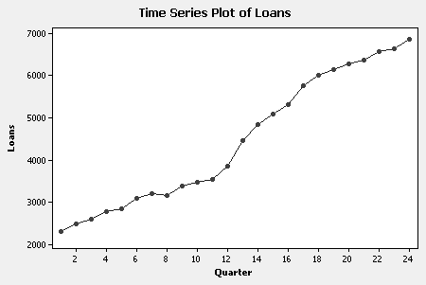

The autocorrelation function follows.

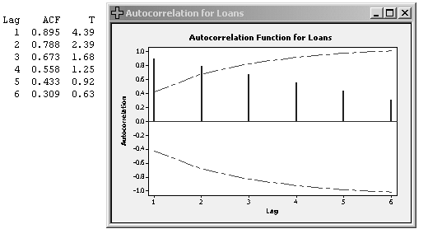
18. a. r₁ = .376

b. The differenced data are stationary. See plot below.

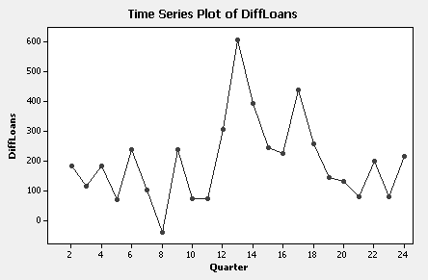

The autocorrelation function follows.

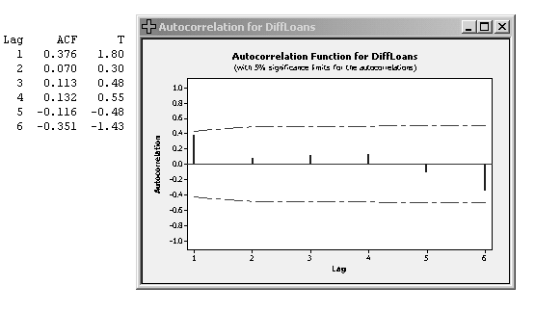

19. Figure 3-18 - The data are nonstationary. (Trending data)
Figure 3-19 - The data are random.
Figure 3-20 - The data are seasonal. (Monthly data)
Figure 3-21 - The data are stationary and have a pattern that could be modeled.
20.

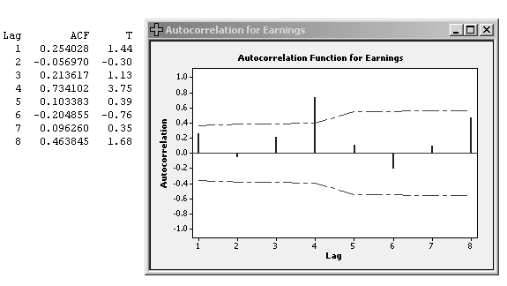

The data have a quarterly seasonal pattern as shown by the significant autocorrelation
at time lag 4. First quarter earnings tend to be high, third quarter earnings tend to be low.
a. Time Data Forecast Error
t Y_{t} $\hat{Y}$_{t} e _{t} $\left|et\right|$ e _{t} ² $\frac{\left|et\right|}{Yt}$ $\frac{et}{Yt}$

1 .40 - - - - - -
2 .29 .40 -.11 .11 .0121 .3793 -.3793
3 .24 .29 -.05 .05 .0025 .2083 -.2083
4 .32 .24 .08 .08 .0064 .2500 .2500
5 .47 .32 .15 .15 .0225 .3191 .3191
6 .34 .47 -.13 .13 .0169 .3824 -.3824
7 .30 .34 -.04 .04 .0016 .1333 -.1333
8 .39 .30 .09 .09 .0081 .2308 .2308
9 .63 .39 .24 .24 .0576 .3810 .3810
10 .43 .63 -.20 .20 .0400 .4651 -.4651
11 .38 .43 -.05 .05 .0025 .1316 -.1316
12 .49 .38 .11 .11 .0121 .2245 .2245
13 .76 .49 .27 .27 .0729 .3553 .3553
14 .51 .76 -.25 .25 .0625 .4902 -.4902
15 .42 .51 -.09 .09 .0081 .2143 -.2143
16 .61 .42 .19 .19 .0361 .3115 .3115
17 .86 .61 .25 .25 .0625 .2907 .2907
18 .51 .86 -.35 .35 .1225 .6863 -.6863
19 .47 .51 -.04 .04 .0016 .0851 -.0851
20 .63 .47 .16 .16 .0256 .2540 .2540
21 .94 .63 .31 .31 .0961 .3298 .3298
22 .56 .94 -.38 .38 .1444 .6786 -.6786
23 .50 .56 -.06 .06 .0036 .1200 -.1200
24 .65 .50 .15 .15 .0225 .2308 .2308
25 .95 .65 .30 .30 .0900 .3158 .3158
26 .42 .95 -.53 .53 .2809 1.2619 -1.2619
27 .57 .42 .15 .15 .0225 .2632 .2632
28 .60 .57 .03 .03 .0009 .0500 .0500
29 .93 .60 .33 .33 .1089 .3548 .3548
30 .38 .93 -.55 .55 .3025 1.4474 -1.4474
31 .37 .38 -.01 .01 .0001 .0270 -.0270
32 .57 .37 .20 .20 .0400 .3509 .3509

5.85 1.6865 11.2227 -2.1988

b. MAD = $\frac{5\text{.}\text{85}}{\text{31}}$ = .189

c. MSE = $\frac{1\text{.}\text{6865}}{\text{31}}$ = .0544 , RMSE = √.0544 = .2332
d. MAPE = $\frac{\text{11}\text{.}\text{2227}}{\text{31}}$ = .3620 or 36.2%

- MPE = $\frac{−2\text{.}\text{1988}}{\text{31}}$ = -.0709

21. a. Time series plot follows

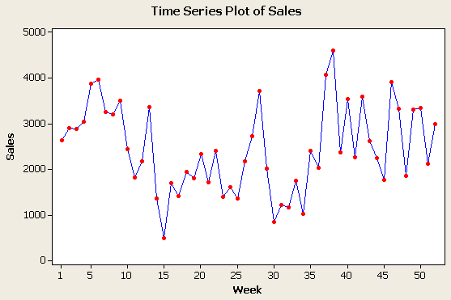

b. The sales time series appears to vary about a fixed level so it is stationary.

c. The sample autocorrelation function for the sales series follows:
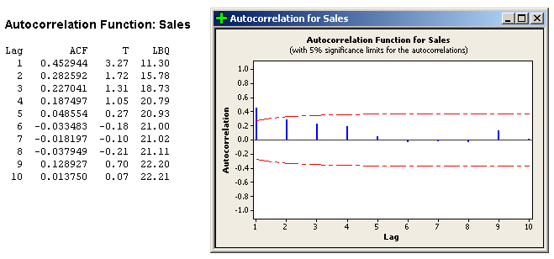

The sample autocorrelations die out rapidly. This behavior is consistent with a
stationary series. Note that the sales data are not random. Sales in adjacent
weeks tend to be positively correlated.

22. a. The residuals $e_{t}=Y_{t}−\bar{Y}$are listed below
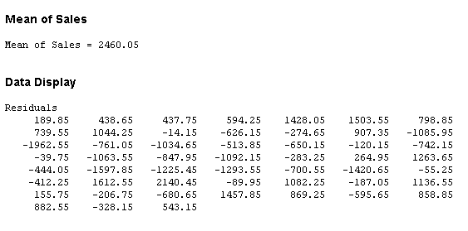

b. The residual autocorrelations follow

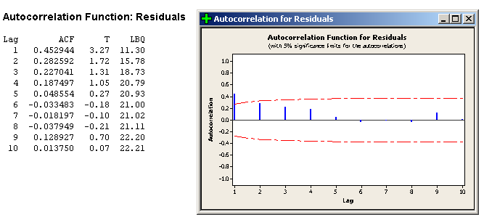

Since, in this case, the residuals differ from the original observations by the
constant $\bar{Y}=\text{2460}\text{.}\text{05}$, the residual autocorrelations will be the same as the
autocorrelations for the sales numbers. There is significant residual
autocorrelation at lag 1 and the autocorrelations die out in an exponential fashion.
The random model is not adequate for these data.

23. a. & b. Time series plot follows.

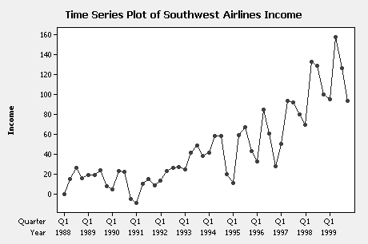

Since this series is trending upward, it is nonstationary. There is also a seasonal
pattern since 2nd and 3rd quarter earnings tend to be relatively large and 1st and 4th
quarter earnings tend to be relatively small.

c. The autocorrelation function for the first 10 lags follows.

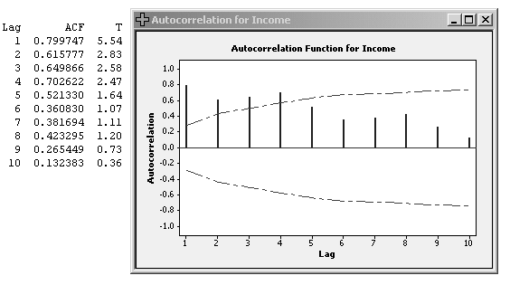

The autocorrelations are consistent with choice in part b. The autocorrelations fail
to die out rapidly consistent with nonstationary behavior. In addition, there are
relatively large autocorrelations at lags 4 and 8, indicating a quarterly seasonal
pattern.

24. a. & b. Time series plot of fourth differences follows.

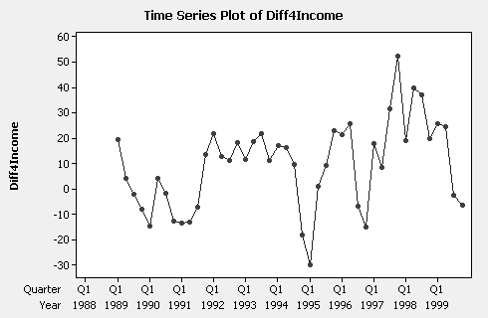

The time series of fourth differences appears to be stationary as it varies
about a fixed level.

25. a. 98/99Inc 98/99For 98/99Err 98/99AbsErr 98/99Err^2 98/99AbE/Inc
70.01 50.87 19.14 19.14 366.34 0.273390
133.39 93.83 39.56 39.56 1564.99 0.296574
129.64 92.51 37.13 37.13 1378.64 0.286409
100.38 80.55 19.83 19.83 393.23 0.197549
95.85 70.01 25.84 25.84 667.71 0.269588
157.76 133.39 24.37 24.37 593.90 0.154475
126.98 129.64 -2.66 2.66 7.08 0.020948
93.80 100.38 -6.58 6.58 43.30 0.070149

Sum 175.11 5015.17 1.5691

b. MAD = 175.11/8 = 21.89, RMSE = √5015.17 = 70.82, MAPE = 1.5691/8 = .196
or 19.6%

c. Naïve forecasting method of part a assumes fourth differences are random.
Autocorrelation function for fourth differences suggests they are not random.
Error measures suggest naïve method not very accurate. In particular, on average,
there is about a 20% error. However, naïve method does pretty well for 1999.
Hard to think of another naïve method that will do better.

CASE 3-1A: MURPHY BROTHERS FURNITURE

1. The retail sales series has a trend and a monthly seasonal pattern.

2. Yes! Julie has determined that her data have a trend and should be first differenced. She has
also found out that the first differenced data are seasonal.

3. Techniques that she should consider include classical decomposition, Winters’
exponential smoothing, time series multiple regression, and Box-Jenkins methods.

4. She will know which technique works best by comparing error measurements such as MAD,
MSE or RMSE, MAPE, and MPE.

CASE 3-1B: MURPHY BROTHERS FURNITURE

1. The retail sales series has a trend and a monthly seasonal pattern.

2. The patterns appear to be somewhat similar. More actual data is needed in order to reach a definitive conclusion.

3. This question should create a lively discussion. There are good reasons to use either set of data. The retail sales series should probably be used until more actual sales data is available.

CASE 3-2: MR. TUX

1. This case affords students an opportunity to learn about the use of autocorrelation functions,
and to continue following John Mosby's quest to find a good forecasting method for his data.
With the use of Minitab, the concept of first differencing data is also illustrated. The
summary should conclude that the sales data have both a trend and a seasonal component.

2. The trend is upward. Since there are significant autocorrelation coefficients at time lags 12
and 24, the data have a monthly seasonal pattern.

3. There is a 49% random component. That is, about half the variability in John’s monthly
sales is not accounted for by trend and seasonal factors. John, and the students analyzing
these results, should realize that finding an accurate method of forecasting these data could
be very difficult.

4. Yes, the first differences have a seasonal component. Given the autocorrelations at lags 12
and 24, the monthly changes are related 12, 24, … months apart. This information should be
used in developing a forecasting model for changes in monthly sales.

CASE 3-3: CONSUMER CREDIT COUNSELING

1. First, Dorothy used Minitab to compute the autocorrelation function for the number of new
clients. The results are shown below.

Since the autocorrelations failed to die out rapidly, Dorothy concluded her series was
trending or nonstationary. She then decided to difference her time series.
The autocorrelations for the first differenced series are:

- The differences appear to be stationary and are correlated in consecutive time periods. Given
the somewhat large autocorrelations at lags 12 and 24, a monthly seasonal pattern should be
considered.

3. Dorothy would recommend that various seasonal techniques such as Winters’ method of
exponential smoothing (Chapter 4), classical decomposition (Chapter 5), time series
multiple regression (Chapter 8) and Box-Jenkins methods (ARIMA models in Chapter 9) be
considered.

CASE 3-4: alomega food stores

The sales data from Chapter 1 for the Alomega Food Stores case are reprinted in Case
3-4. The case suggests that Julie look at the data pattern for her sales data.

The autocorrelation function for sales follows.

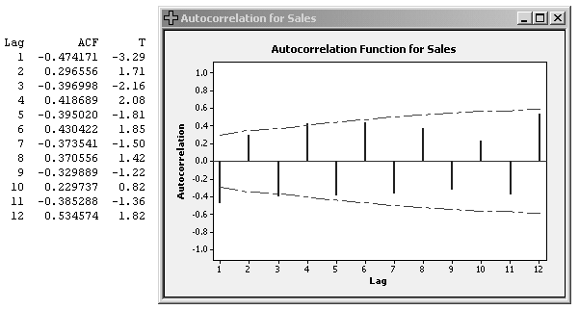

Autocorrelations suggest an up and down pattern that is very regular. If one month is relatively high, next month tends to be relatively low and so forth. Very regular
pattern is suggested by persistence of autocorrelations at relatively large lags.

The changing of the sign of the autocorrelations from one lag to the next is consistent with
an up and down pattern in the time series. If high sales tend to be followed by low sales or
low sales by high sales, autocorrelations at odd lags will be negative and autocorrelations at even lags positive.

The relatively large autocorrelation at lag 12, 0.53, suggests there may also be a seasonal
pattern. This issue is explored in Case 5-6.

CASE 3-5: SURTIDO COOKIES

1. A time series plot and the autocorrelation function for Surtido Cookies sales follow.

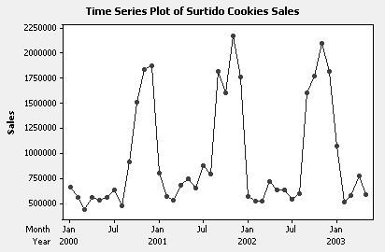

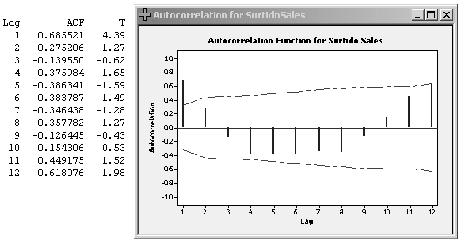

The graphical evidence above suggests Surtido Cookies sales vary about a fixed level with
a strong monthly seasonal component. Sales are typically high near the end of the year and
low during the beginning of the year.

2. 03Sales NaiveFor Err AbsErr AbsE/03Sales MAD = 678369/5 = 135674
1072617 681117 391500 391500 0.364995 MAPE = .816833/5 = .163 or 16.3%
510005 549689 -39684 39684 0.077811
579541 497059 82482 82482 0.142323
771350 652449 118901 118901 0.154147
590556 636358 -45802 45802 0.077557
Sum 678369 0.816833

MAD appears large because of the big numbers for sales. MAPE is fairly large but
perhaps tolerable. In any event, Jame is convinced he can do better.
CHAPTER 4

MOVING AVERAGES AND SMOOTHING METHODS

ANSWERS TO PROBLEMS AND CASES

1. Exponential smoothing

2. Naive

3. Moving average

4. Holt's two-parameter smoothing procedure

5. Winters’ three-parameter smoothing procedure

6. a.

t Y_{t} ${\hat{Y}}_{t}$ e _{t} $\left|et\right|$ e _{t} ² $\frac{\left|et\right|}{Yt}$ $\frac{et}{Yt}$

1 19.39 19.00 .39 .39 .1521 .020 .020
2 18.96 19.39 - .43 .43 .1849 .023 -.023
3 18.20 18.96 - .76 .76 .5776 .042 -.042
4 17.89 18.20 - .31 .31 .0961 .017 -.017
5 18.43 17.89 .54 .54 .2916 .029 .029
6 19.98 18.43 1.55 1.55 2.4025 .078 .078
7 19.51 19.98 - .47 .47 .2209 .024 -.024
8 20.63 19.51 1.12 1.12 1.2544 .054 .054
9 19.78 20.63 - .85 .85 .7225 .043 -.043
10 21.25 19.78 1.47 1.47 2.1609 .069 .069
11 21.18 21.25 - .07 .07 .0049 .003 -.003
12 22.14 21.18 .96 .96 .9216 .043 .043

8.92 8.990 .445 .141

b. MAD = $\frac{8\text{.}\text{92}}{\text{12}}$ = .74

c. MSE = $\frac{8\text{.}\text{99}}{\text{12}}$ = .75

- MAPE = $\frac{\text{.}\text{445}}{\text{12}}$= .0371

e. MPE = $\frac{\text{.}\text{141}}{\text{12}}$ = .0118

f. 22.14

7.
Price AVER1 FITS1 RESI1
19.39 * * *
18.96 * * *
18.20 18.8500 * *
17.89 18.3500 18.8500 -0.96000
18.43 18.1733 18.3500 0.08000
19.98 18.7667 18.1733 1.80667
19.51 19.3067 18.7667 0.74333
20.63 20.0400 19.3067 1.32333
19.78 19.9733 20.0400 -0.26000
21.25 20.5533 19.9733 1.27667
21.18 20.7367 20.5533 0.62667
22.14 21.5233 20.7367 1.40333

Accuracy Measures
MAPE: 4.6319 MAD: 0.9422 MSE: 1.1728

The naïve approach is better.

8. a. See plot below.

Y_{t} Avg Fits Res
200 * * *
210 * * *
215 * * *
216 * * *
219 212 * *
220 216 212 8
225 219 216 9
226 221.2 219 7
221.2

Accuracy Measures
MAPE: 3.5779 MAD: 8.0000 MSE: 64.6667

221.2 is forecast for period 9

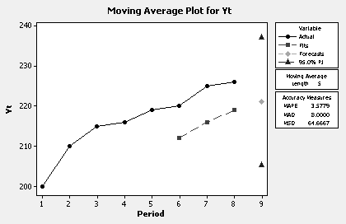

b. & c. See plot below.

Y_{t} Smoothed Forecast
200 200.000 200.000
210 204.000 200.000
215 208.400 204.000
216 211.440 208.400
219 214.464 211.440
220 216.678 214.646
225 220.007 216.678
226 222.404 220.007
222.404

Accuracy Measures
MAPE: 3.2144 MAD: 7.0013 MSE: 58.9657

Caution: If Minitab is used, the final result depends on how many
values are averaged for the initial value. If 1 value is averaged, so in
this case the initial value is 200, the forecast for period 4 is 208.4.

The forecast error for time period 3 is 11.
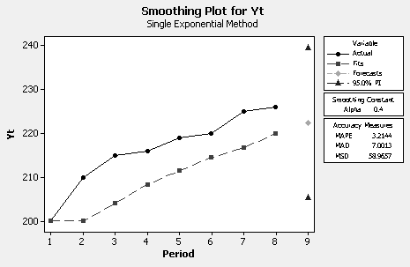

9. a. & c, d, e, f 3-month moving-average (See plot below.)

Month Yield MA Forecast Error
1 9.29 * * *
2 9.99 * * *
3 10.16 9.813 * *
4 10.25 10.133 9.813 0.437
5 10.61 10.340 10.133 0.477
6 11.07 10.643 10.340 0.730
7 11.52 11.067 10.643 0.877
8 11.09 11.227 11.067 0.023
9 10.80 11.137 11.227 -0.427
10 10.50 10.797 11.137 -0.637
11 10.86 10.720 10.797 0.063
12 9.97 10.443 10.720 -0.750

Accuracy Measures
MAPE: 4.5875 MAD: 0.4911 MSE: 0.3193 MPE: .6904

Forecast for month 13 (Jan.) is 10.443
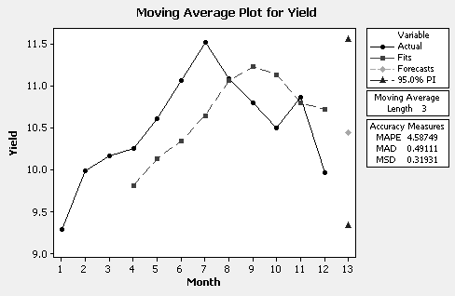

b. & c, d, e, f 5-month moving-average (See plot below.)

Month Yield MA Forecast Error
1 9.29 * * *
2 9.99 * * *
3 10.16 * * *
4 10.25 * * *
5 10.61 10.060 * *
6 11.07 10.416 10.060 1.010
7 11.52 10.722 10.416 1.104
8 11.09 10.908 10.722 0.368
9 10.80 11.018 10.908 -0.108
10 10.50 10.996 11.018 -0.518
11 10.86 10.954 10.996 -0.136
12 9.97 10.644 10.954 -0.984

Accuracy Measures
MAPE: 5.5830 MAD: 0.6040 MSE: 0.5202 MPE: .7100

Forecast for month 13 (Jan.) is 10.644
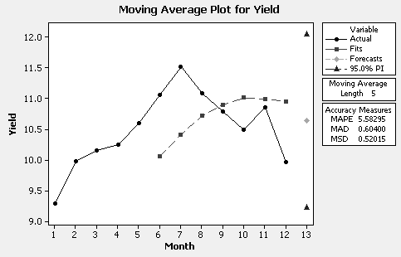

g. Use 3-month moving average forecast: 10.4433

10. Accuracy Measures (See plot below.)

MAPE: 5.8926 MAD: 0.6300 MSE: 0.5568 MPE: 5.0588

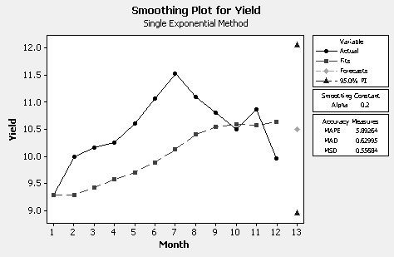

Forecast for month 13 (Jan. 2007) is 10.4996

No! The accuracy measures favor the three-month moving average procedure, but the
values of the forecasts are not much different.
11. See plot below.

Month Demand Smooth Forecast Error

1 205 205.000 205.000 0.0000
2 251 228.000 205.000 46.0000
3 304 266.000 228.000 76.0000
4 284 275.000 266.000 18.0000
5 352 313.500 275.000 77.0000
6 300 306.750 313.500 -13.5000
7 241 273.875 306.750 -65.7500
8 284 278.938 273.875 10.1250
9 312 295.469 278.938 33.0625
10 289 292.234 295.469 -6.4688
11 385 338.617 292.234 92.7656
12 256 297.309 338.617 -82.6172

Accuracy Measures
MAPE: 14.67 MAD: 43.44 MSE: 2943.24

Forecast for month 13 (Jan. 2007) is 297.309

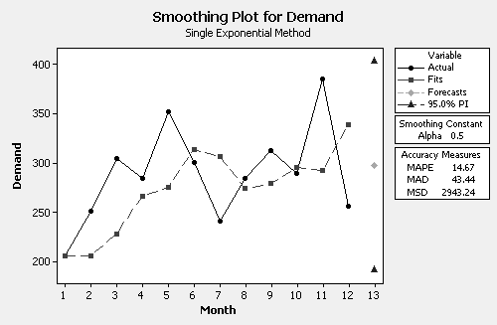

12. Naïve method - Forecast for 1996 Q2: 25.68 (Actual: 26.47)
MAPE = 8.622 MAD = 1.916 MSE = 5.852

5-month moving average - Forecast for 1996 Q2: 24.244 (Actual: 26.47)
MAPE: 9.791 MAD: 2.249 MSE: 7.402

Exponential smoothing with a Smoothing Constant of Alpha: 0.696
MAPE: 8.425 MAD: 1.894 MSE: 5.462

Forecast for 1996 Q2: 25.227 (Actual: 26.47)

Based on the error measures and the forecast for Q2 of 1996, the naïve method
and simple exponential smoothing are comparable. Either method could be used.

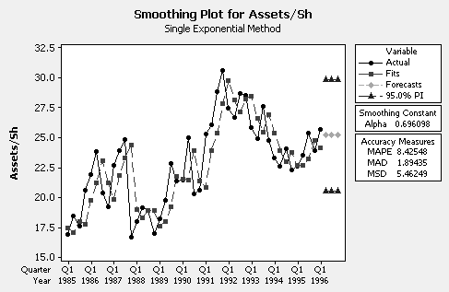

13. a. α = .4

Accuracy Measures
MAPE: 14.05 MAD: 24.02 MSE: 1174.50

Forecast for Q1 2000: 326.367

b. α = .6

Accuracy Measures
MAPE: 14.68 MAD: 24.56 MSE: 1080.21

Forecast for Q1 2000: 334.070

c. Looking at the error measures, there is not much difference between the two
choices of smoothing constant. The error measures for α = .4 are slightly better.
The forecasts for the two choices of smoothing constant are also not much different.
d. The residual autocorrelations for α = .4 are shown below. The residual autocorrelations for α = .6 are similar. There are significant residual autocorrelations at lags 1, 4 and (very nearly) 8. A forecasting method that yields no significant residual autocorrelations would be desirable.

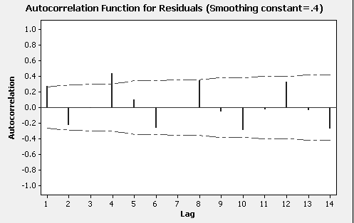

14. None of the techniques do much better than the naïve method. Simple exponential
Smoothing with α close to 1, say .95, is essentially the naïve method.

Accuracy Measures for Naïve Method
MAPE: 42.57 MAD: 1.685 MSD: 4.935

Using the naïve method, the forecast for 2000 would be 6.85.

15. A time series plot of quarterly Revenues and the autocorrelation function show
that the data are seasonal with a trend. After some experimentation, Winters’
multiplicative smoothing with smoothing constants α (level) = 0.8, β (trend) = 0.1
and γ (seasonal) = 0.1 is used to forecast future Revenues. See plot below.

Accuracy Measures

MAPE 3.8
MAD 69.1
MSE 11146.4

Forecasts

Quarter Forecast Lower Upper
71 2444.63 2275.34 2613.92
72 1987.98 1773.84 2202.12
73 2237.98 1969.23 2506.72
74 1887.74 1559.46 2216.01
75 2456.18 2065.70 2846.65
76 1997.36 1543.10 2451.62

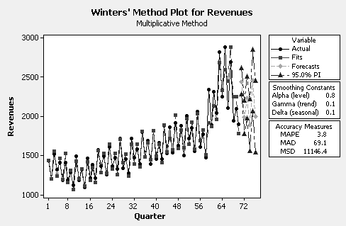

An examination of the autocorrelation coefficients for the residuals from
Winters’ multiplicative smoothing shown below indicates that none of them
are significantly different from zero.

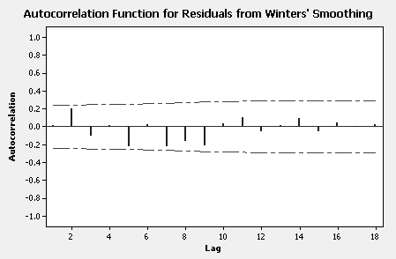
16. a. An Excel time series plot for Sales follows
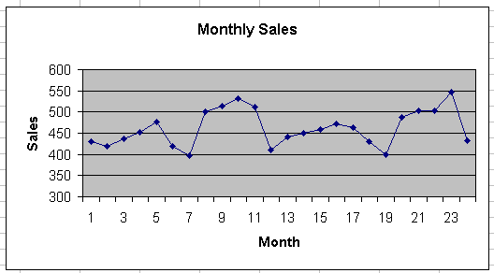

The data appear to be seasonal with relatively large sales in August, September,
October and November, and relatively small sales in July and December.

b. & c. The Excel spreadsheet for calculating MAPE for the naïve forecasts and
the simple exponential smoothing forecasts is shown below.

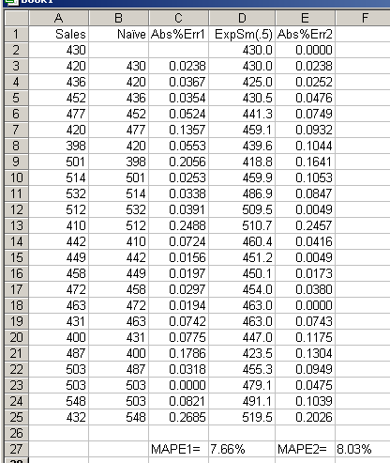

Note: MAPE2 for simple exponential smoothing in the Excel spreadsheet
is calculated with a divisor of 23 (since the first smoothed value is set equal to the first observation). Using a divisor of 24 gives MAPE2 = 7.69%, the value reported by Minitab.

d. Neither the naïve model nor simple exponential smoothing is likely to
generate accurate forecasts of future monthly sales since neither model
allows for seasonality.

e. The results of Winters’ multiplicative smoothing with α = β = γ = .5 is
shown in the Minitab plot below.

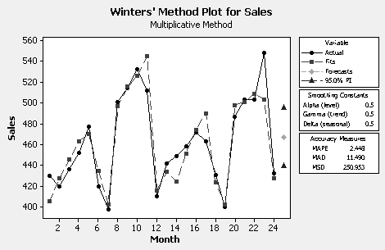

The forecast for January, 2003 is 467.

f. From part e, MAPE = 2.45%. Prefer Winters’ multiplicative smoothing
since it allows for seasonality and has the smallest MAPE of the three
models considered.

g. The residual autocorrelations from Winters’ multiplicative smoothing are
shown below. The residual autocorrelations suggest Winters’ method
works well for these data since they are all insignificantly different from 0.

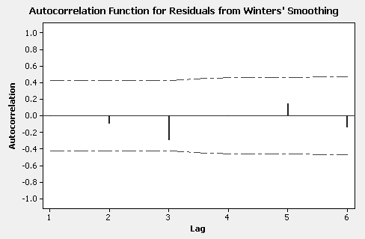

17. a. The four-week moving average seems to represent the data a little better.
Compare the error measures for the four-week moving average in the figure below
with the five-week moving average results in Figure 4-4.

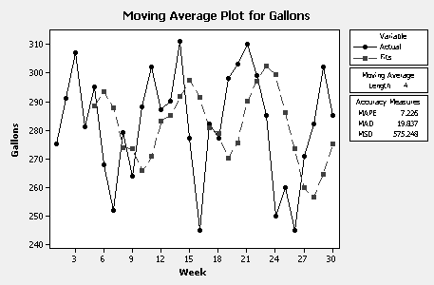

b. Simple exponential smoothing with a smoothing constant of α = .7 does a
better job of smoothing the data than a four-week moving average as judged
by the uniformly smaller error measures shown in the plot below.

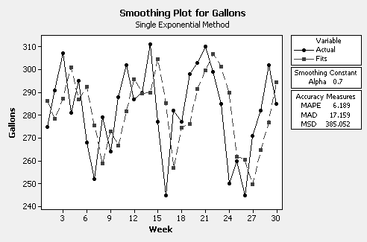

18. a. As the order of the moving average increases, the smoothed data become more
wavelike. Looking at the results for orders k =10 and k = 15, and counting the
number of years from one peak to the next, it appears as if the number of severe
earthquakes is on about a 30 year cycle.

b. The results of simple exponential smoothing with a smoothing constant of α = .4
are shown in the plot below. The forecast for the number of severe earthquakes
for 2000 is 20.

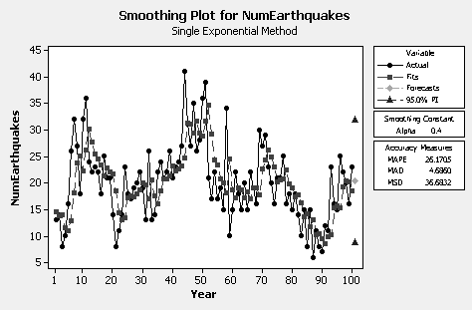

The residual autocorrelation function is shown below. There are no
significant residual autocorrelations. Simple exponential smoothing seems
to provide a good fit to the earthquake data.

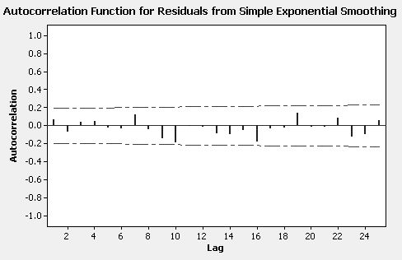

c. There can be no seasonal component in the number of severe earthquakes since these data are recorded on an annual basis.

19. a. The results of Holt’s smoothing with α (level) = .9 and β (trend) = .1 for
Southwest Airline’s quarterly income are shown below. A plot of the residual autocorrelation function follows. It appears as if Holt’s procedure represents the data well but the residual autocorrelations have significant spikes at the seasonal lags of 4 and 8 suggesting a seasonal component is not captured by Holt’s method.

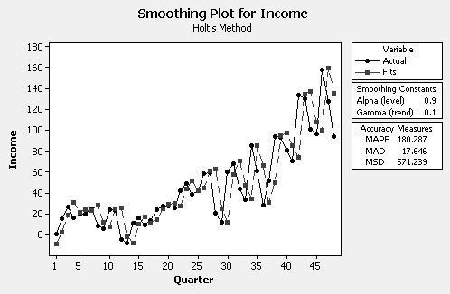

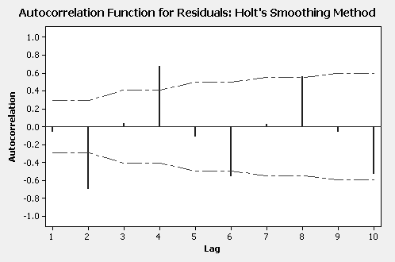

b. Winters’ multiplicative smoothing with α = β = γ =.2 was applied to the quarterly
income data and the results are shown in the plot below. The forecasts for the
four quarters of 2000 are:

Quarter Forecast
49 88.960
50 184.811
51 181.464
52 117.985

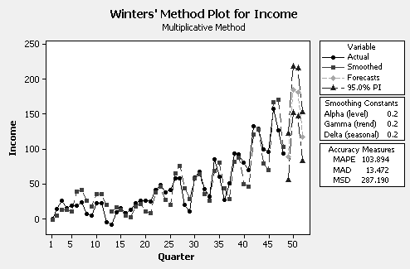

The forecasts seem reasonable but the residual autocorrelation function below has
a significant spike at lag 1. So although Winters’ procedure captures the trend and
seasonality, there is still some association in consecutive observations not
accounted for by Winters’ method.

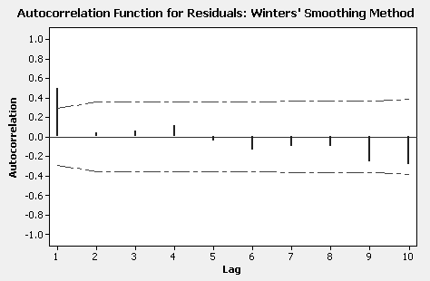

- A time series plot of The Gap quarterly sales is shown below.

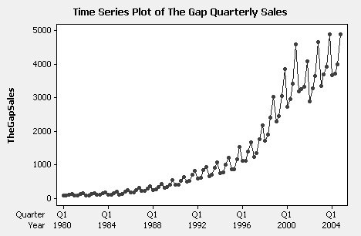

This time series is trending upward and has a seasonal pattern with third and fourth
quarter Gap sales relatively large. Moreover the variability in this series is increasing
with the level suggesting a multiplicative Winters’ smoothing procedure or a
transformation of the data (say logarithms of sales) to stabilize the variability.

The results of Winters’ multiplicative smoothing with smoothing constants
α = β = γ =.2 are shown in the plot below.

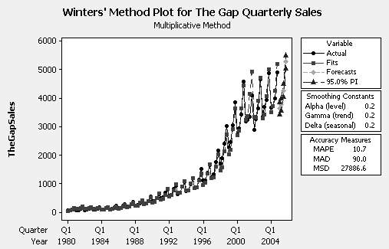
The forecasts for the four quarters of 2005 are:

Forecasts

Quarter Forecast Lower Upper
101 3644.18 3423.79 3864.57
102 3775.78 3551.94 3999.62
103 4269.27 4041.58 4496.96
104 5267.82 5035.90 5499.74

The forecasts seem reasonable, however, the residuals autocorrelations shown
below indicate there is still some autocorrelation at low lags, including the
seasonal lag S = 4, that is not accounted for by Winters’ method. A better
model is needed. This issue is explored in later chapters of the text.

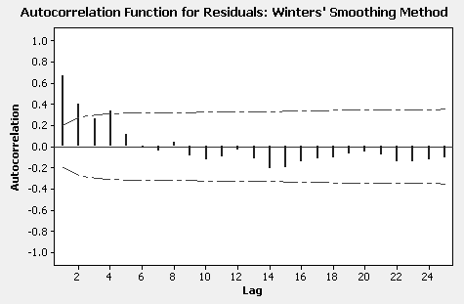

CASE 4-1: THE SOLAR ALTERNATIVE COMPANY

This case provides the student with an opportunity to deal with a frequent real world problem: small data sets. A plot of the two years of data shows both an upward trend and seasonal pattern. The forecasting model that is selected must do an accurate job for at least three months into the future.

Averaging methods are not appropriate for this data set because they do not work when data has a trend, seasonality, or some other systematic pattern. Moving average models tend to smooth out the seasonal pattern of the data instead of making use of it to forecast.

A naive model that takes into account both the trend and the seasonality of the data might work. Since the seasonal pattern appears to be strong, a good forecast might take the same value it did in the corresponding month one year ago or Y_{t+1} = Y_{t-11}.

However, as it stands, this forecast ignores the trend. One approach to estimate trend is to calculate the increase from each month in 2005 to the same month in 2006. As an example, the increase from January, 2005 to January, 2006 is equal to (Y₁₃ - Y₁) = (17 - 5) = 12.
After the increases for all 12 months are calculated, they can be summed and then divided by 12. The forecast for each month of 2007 could then be calculated as the value for the same month in 2006 plus the average increase for each of the 12 months from 2005 to the same month in 2006. Consequently, the forecast for January, 2007 is

Y₂₅ = 17 + [(17 - 5) + (14 - 6) + (20 - 10) + (23 - 13) + (30 - 18) + (38 - 15) + (44 - 23) +
(41 - 26) + (33 - 21) + (23 - 15) + (26 - 12) + (17 - 14)]/12

Y₂₅ = 17 + $\frac{\text{148}}{\text{12}}$ = 17 + 12 = 29

The forecasts for 2007 are: Jan 29
Feb 26
Mar 32
Apr 35
May 42
Jun 50
Jul 56
Aug 53
Sep 45
Oct 35
Nov 38
Dec 29

Winters’ multiplicative method with smoothing constants α = .1, β = .1, γ = .3 seems to
represent the data fairly well (see plot below) and produces the forecasts:

Month Forecast
Jan/2007 19.8
Feb/2007 18.0
Mar/2007 26.8
Apr/2007 32.0
May/2007 42.4
Jun/2007 45.8
Jul/2007 58.4
Aug/2007 58.9
Sep/2007 47.6
Oct/2007 33.7
Nov/2007 33.5
Dec/2007 28.0

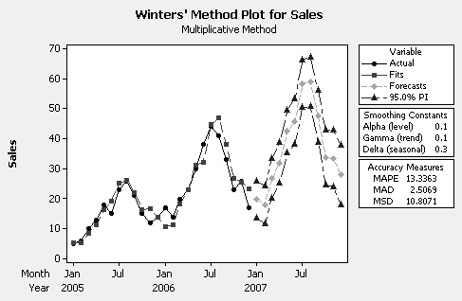

The naïve forecasts are not unreasonable but the Winters’ forecasts seem to have captured the seasonal pattern a little better, particularly for the first 3 months of the year. Notice that if the trend and seasonal pattern are strong, Winters’ smoothing procedure can work well even with only two years of monthly data.

CASE 4-2: MR TUX

This case shows how several exponential smoothing methods can be applied to the Mr. Tux data. John Mosby tries simple exponential smoothing and exponential smoothing with adjustments for trend and seasonal factors, along with a three-month moving average.
Students can begin to see that several forecasting methods are typically tried when an important variable must be forecast. Some method of comparing them must be used, such as the three accuracy methods discussed in this case. Students should be asked their opinions of John's progress in his forecasting efforts given these accuracy values. It should be apparent to most that the degree of accuracy achieved is not sufficient and that further study is needed. Students should be reminded that they are looking at actual data, and that the problems faced by John Mosby really occurred.

1. Of the methods attempted, Winters’ multiplicative smoothing was the best method John
found. Each forecast was typically off by about 25,825. The error in each forecast was
about 22% of the value of the variable being forecast.

2. There are other choices for the smoothing constants that lead to smaller error measures.
For example, with α = β = γ = .1, MAD = 22,634 and MAPE = 20.

3. John should examine plots of the residuals and the residual autocorrelations. If Winters’
procedure is adequate, the residuals should appear to be random. In addition, John can
examine the forecasts for the next 12 months to see if they appear to be reasonable.

4. The ideal value for MPE is 0. If MPE is negative, then, on average, the predicted values
are too high (larger than the actual values).

CASE 4-3: CONSUMER CREDIT COUNSELING

- Students should realize immediately that simply using the basic naive approach of
using last period to predict this period will not allow for forecasts for the rest of
1993. Since the autocorrelation coefficients presented in Case 3-3 indicate
some seasonality, a naive model using April 1992 to predict April 1993, May 1992 to
predict May 1993 and so forth might be tried. This approach produces the error
measures

MAD = 23.39 MSE = 861.34 MAPE = 18.95

over the data region, and are not particularly attractive given the magnitudes of the new
client numbers.

- A moving average model of any order cannot be defended since any moving average
will produce flat line forecasts for the rest of 1993. That is, the forecasts will lie along a
horizontal line whose level is the last value for the moving average. The seasonal pattern
will be ignored.

- Since the data have a seasonal component, Winters’ multiplicative smoothing
procedure with smoothing constants α = β = γ =.2 was tried. For these choices:
MAD = 19.29, MSE = 545.41 and MAPE = 16.74. For smoothing constants α = .5,
β = γ = .1, MAD = 16.94, MSE = 451.26 and MAPE = 14.30.

4. Of the methods attempted, the Winters’ multiplicative smoothing procedure
with smoothing constants α = .5, β = γ = .1 is best based on MAD, MSD, and MAPE.

5. Using Winters’ procedure in 4, the forecasts for the remainder of 1993 are:

Month Forecast
Apr/1993 148
May/1993 141
Jun/1993 148
Jul/1993 141
Aug/1993 143
Sep/1993 136
Oct/1993 159
Nov/1993 146
Dec/1993 126

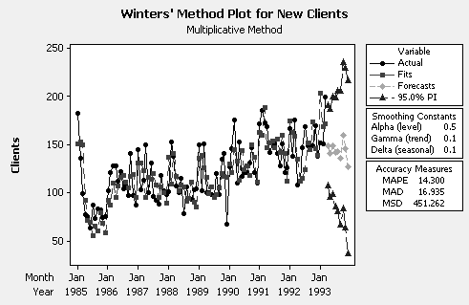

6. There are no significant residual autocorrelations (see plot below). Winters’
multiplicative smoothing seems adequate.

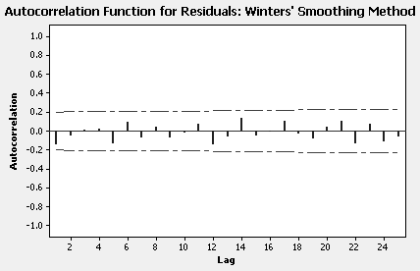

CASE 4-4: MURPHY BROTHERS FURNITURE

- No adequate smoothing model was found! A Winters’ multiplicative model using
α = .3, β = .2 and γ = .1 was deemed the best but there was still some significant
residual autocorrelation.

- Yes. A Winters’ multiplicative smoothing procedure with α = .8, β = .1 and γ = .1 was adequate. Also, a naïve model that combined seasonal and trend estimates (similar to Equation 4.5) was found to be adequate. The trend and seasonal pattern in actual
Murphy Brother’s sales are consistent and pronounced so a naïve model is likely to
work well.

- Based on the forecasting methods tested, actual Murphy Brother’s sales data should be used. A plot of the results for the best Winters’ procedure follows.

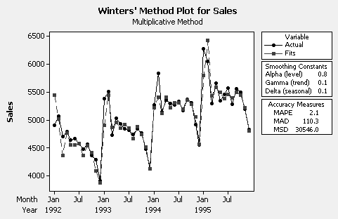

An examination of the autocorrelation coefficients for the residuals from this Winters’
model shown below indicates that none of them are significantly different from zero.

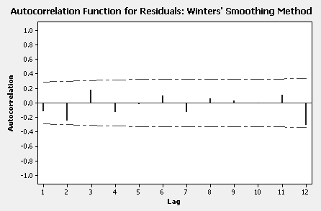
However, Julie decided to use the naïve model because it was very simple and she could explain it to her father.

CASE 4-5: FIVE-YEAR REVENUE PROJECTION FOR DOWNTOWN RADIOLOGY

This case is designed to emphasize the use of subjective probability estimates in a
forecasting situation. The methodology used to generate revenue forecasts is both appropriate
and accurately employed. The key to answering the question concerning the accuracy of the projections hinges on the accuracy of the assumptions made and estimates used. Examination
of the report indicates that the analysts were conservative each time they made an assumption or computed an estimate. This is probably one of the major reasons why the Professional
Marketing Associates’ (PMA) forecast is considerably lower. Since we do not know how the accountant projected the number of procedures, it is difficult to determine why his revenue projections were higher. However, it is reasonable to assume that his forecast of the number
of cases for each type of procedure was not nearly as sophisticated or thorough as PMAs.
Therefore, the recommendation to management should indicate that the PMA forecast, while
probably on the conservative side, is more likely to be accurate.
Downtown Radiology evidently agreed with PMA's forecast. They decided not to
purchase a 9,800 series CT scanner. They also decided to purchase a less expensive MRI.
Finally, they decided to obtain outside funding and did not resort to any type of public offering.
They built their new imaging center, purchased an MRI and have created a very successful
imaging center.

CASE 4-6: WEB RETAILER

1. The time series plot for Orders shows a slight upward trend and a seasonal pattern
with peaks in December. Because of the relatively small data set, the autocorrelations
are only computed for a limited number of lags, 6 in this case. Consequently with
monthly data, the seasonality does not show up in the autocorrelation function. There
is significant positive autocorrelation at lag 1, so Orders in consecutive months are
correlated.

The time series plot for CPO shows a downward trend but a seasonal component is
not readily apparent. There is significant positive autocorrelation at lag 1 and the
autocorrelations die out relatively slowly. The CPO series is nonstationary and
observations in consecutive time periods are correlated.

2. Winters’ multiplicative smoothing with α = β = γ = .1 works well (see plot below).
Forecasts for the next 4 months follow. Residual autocorrelation function below
has no significant autocorrelations.

Month Forecast Lower Upper
Jul/2003 3524720 3072265 3977174
Aug/2003 3885780 3431589 4339972
Sep/2003 3656581 3200544 4112618
Oct/2003 4141277 3683287 4599266

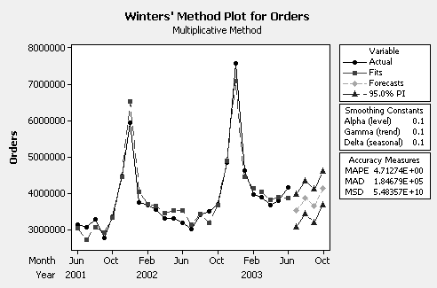

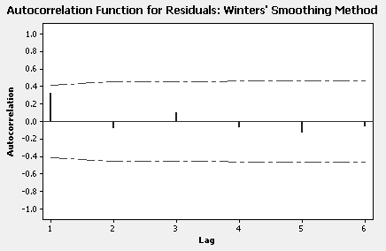

3. Simple exponential smoothing with α = .77 (the optimal α in Minitab) represents the
the CPO data well but, like any “averaging” procedure, produces flat-line forecasts.
Forecasts of CPO for the next 4 months are:

Month Forecast Lower Upper
Jul/2003 0.1045 0.0787 0.1303
Aug/2003 0.1045 0.0787 0.1303
Sep/2003 0.1045 0.0787 0.1303
Oct/2003 0.1045 0.0787 0.1303
The results for simple exponential smoothing are pictured below. There are no
significant residual autocorrelations (see plot below).

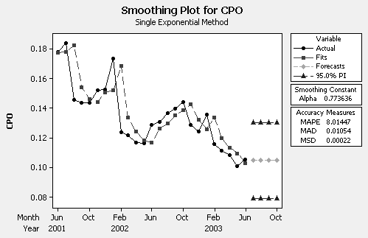

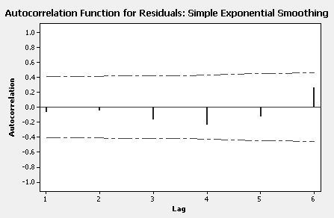

4. Multiplying the Orders forecasts in 2 by the CPO forecasts in 3 gives the
Contacts forecasts:

Month Forecast
Jul/2003 368333
Aug/2003 406064
Sep/2003 382113
Oct/2003 432763

5. It seems reasonable to forecast Contacts directly if the data are available.
Multiplying a forecast of Orders by a forecast of CPO to get a forecast of Contacts
has the potential for introducing additional error (uncertainty) into the process.

6. It may or may not be better to focus on the number of units and contacts per unit
to get a forecast of contacts. It depends on the nature of the data (ease of modeling)
and the amount of relevant data available.

CASE 4-7: SOUTHWEST MEDICAL CENTER

1. Autocorrelation function for total visits suggests time series is nonstationary
(since autocorrelations slow to die out) and seasonal (relatively large autocorrelation
at lag 12).

2. There is no adequate smoothing method to represent Mary’s data. Winters’
multiplicative smoothing with α = β = .5 and γ = .2 seems to do as well as any
smoothing procedure (see error measures in plot below). Forecasts for the remainder
of FY2003-04 generated by Winters’ procedure follow.

Month Forecast Lower Upper
Mar/2004 1465.8 1249.9 1681.7
Apr/2004 1490.5 1252.6 1728.4
May/2004 1453.7 1189.3 1718.1
Jun/2004 1465.4 1171.2 1759.6
Jul/2004 1568.7 1242.3 1895.1
Aug/2004 1552.7 1192.4 1913.0

Forecasts seem high. Residual autocorrelation function pictured below indicates
some remaining significant autocorrelation not captured by Winters’ method.

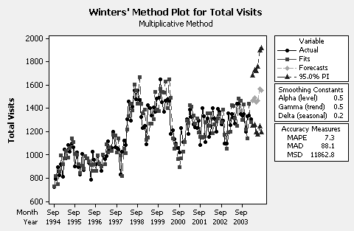

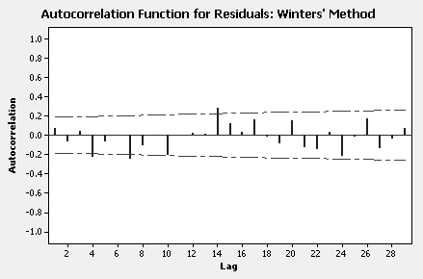

3. If another forecasting method can adequately account for the autocorrelation
in the Total Visits data, it is likely to produce “better” forecasts. This issue
is explored in subsequent cases.

4. The forecasts from Winters’ smoothing show an upward trend. If they are
to be believed, perhaps additional medical staff are required to handle the
expected increased demand. At this point however, further study is required.

CASE 4-8: SURTIDO COOKIES

1. Jame learned that Surtido Cookie sales have a strong seasonal pattern
(sales are relatively high during the last two months of the year, low during
the spring) with very little, if any, trend (see Case 3-5).

2. The autocorrelation function for sales (see Case 3-5) is consistent with
the time series plot. The autocorrelations die out (consistent with no
trend) and have a spike at the seasonal lag 12 (consistent with a seasonal
component).

3. Winters’ multiplicative smoothing with α = β = γ = .2 seems to represent the
data fairly well and produce reasonable forecasts (see plot below). However,
there is still some significant residual autocorrelation at low lags.

Month Forecast Lower Upper
Jun/2003 653254 91351 1215157
Jul/2003 712159 141453 1282865
Aug/2003 655889 75368 1236411
Sep/2003 1532946 941647 2124245
Oct/2003 1710520 1107533 2313507
Nov/2003 2133888 1518354 2749421
Dec/2003 1903589 1274702 2532476

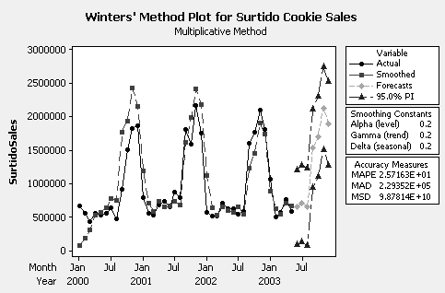

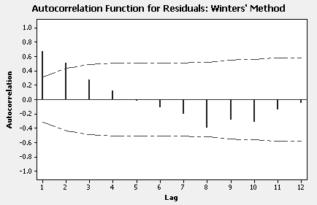

4. Karin’s forecasts follow.

Month Forecast
Jun/2003 618914
Jul/2003 685615
Aug/2003 622795
Sep/2003 1447864
Oct/2003 1630271
Nov/2003 2038257
Dec/2003 1817989

These forecasts have the same pattern as the forecasts generated by Winters’
method but are uniformly lower. Winters’ forecasts seem more consistent
with recent history.

CHAPTER 5

TIME SERIES AND THEIR COMPONENTS

ANSWERS TO PROBLEMS AND CASES

1. The purpose of decomposing a time series variable is to observe its various elements
in isolation. By doing so, insights into the causes of the variability of the series are
frequently gained. A second important reason for isolating time series components
is to facilitate the forecasting process.

2. The multiplicative components model works best when the variability of the time
series increases with the level. That is, the values of the series spread out as the
trend increases, and the set of observations have the appearance of a megaphone
or funnel.

3. The basic forces that affect and help explain the trend-cycle of a series are
population growth, price inflation, technological change, and productivity increases.

4. a. Exponential

- Growth curve (Gompertz)

c. Linear

5. Weather and the calendar year such as holidays affect the seasonal component.

6. a. & b.
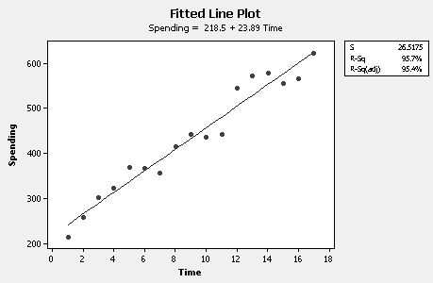
c. 23.89 billion

d. 648.5 billion

e. The trend estimate is below Value Line’s estimate of 680 billion.

f. Inflation, population growth, and new technology affect the trend of capital
spending.

7. a. & b.
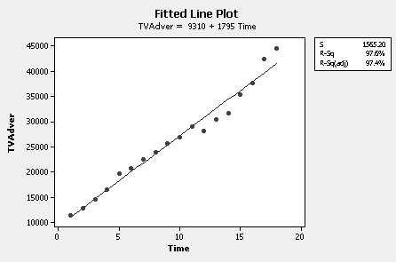

c. $\overline{Y}$ = 9310 + 1795(19) = 43,415

d. Cyclical component might be indicated because of wavelike behavior of
observations about fitted straight line. However, if there is a cyclical affect, it
is very slight.

8. Median equals $(\text{109}\text{.}8+\text{105}\text{.}9)/2$ = 107.85

9. $\hat{Y}$ = TS = 850(1.12) = $952

10. (80.0 + 85.4)/2 = 82.7

$\hat{Y}$ = TS = 900(.827) = $744.3

11. All of the statements are correct except d.

12. Sales Seasonal Deseasonalized
Month ($ Thousands) Index (%) Data

Jan 125 51 245
Feb 113 50 226
Mar 189 87 217
Apr 201 93 216
May 206 95 217
Jun 241 99 243
Jul 230 96 240
Aug 245 89 275
Sep 271 103 263
Oct 291 120 243
Nov 320 131 244
Dec 419 189 222

The statement is not true. When the data are deseasonalized, it shows that business
is about the same.

13. a. & b. Would use both the trend and seasonal indices to forecast although seasonal
component is not strong in this example (see plot and seasonal indices below).

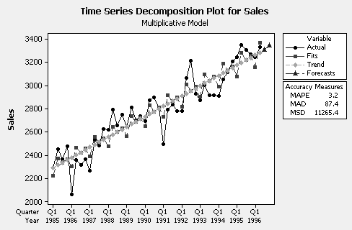

Fitted Trend Equation

Yt = 2268.0 + 22.1*t

Seasonal Indices

Period Index
1 0.969
2 1.026
3 1.000
4 1.005

Forecasts

Period Forecast
Q3/1996 3305.39
Q4/1996 3343.02

c. The forecast for third quarter is a bit low compared to Value
Line’s forecast (3,305 versus 3,340). The forecast for fourth quarter
is a bit high compared to Value Line’s (3,343 versus 3,300).
Additional plots associated with the decomposition follow.

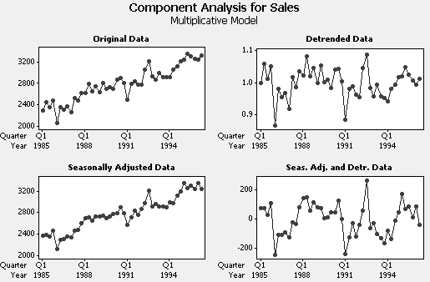

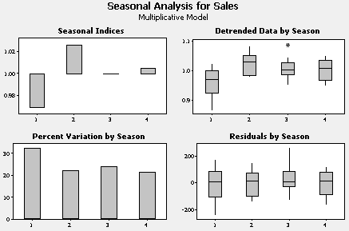

14. a. Multiplicative Model

Data Cavanaugh Sales
Length 77
NMissing 0

Fitted Trend Equation

Yt = 72.6 + 6.01*t

Seasonal Indices

Period Index
1 1.278
2 0.907
3 0.616
4 0.482
5 0.426
6 0.467
7 0.653
8 0.863
9 1.365
10 1.790
11 1.865
12 1.288

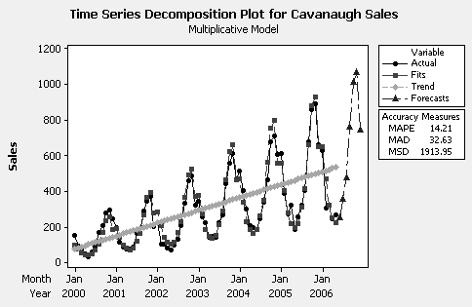

b. Pronounced trend and seasonal components. Would use both for
forecasting.

c. Forecasts (see plot in part a)

Month Forecast
Jun/2006 253
Jul/2006 358
Aug/2006 478
Sep/2006 764
Oct/2006 1012
Nov/2006 1066
Dec/2006 744

15. a. Additive Model

Data LnSales
Length 77
NMissing 0

Fitted Trend Equation

Yt = 4.6462 + 0.0215*t

Seasonal Indices

Period Index
1 0.335
2 -0.018
3 -0.402
4 -0.637
5 -0.714
6 -0.571
7 -0.273
8 -0.001
9 0.470
10 0.723
11 0.747
12 0.342

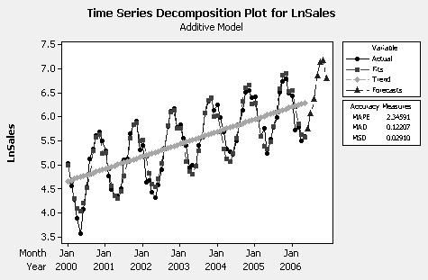

b. Pronounced trend and seasonal components. Would use both to forecast.

c. & d. Forecasts

Month Forecast of LnSales Forecast of Sales
Jun/2006 5.75297 315
Jul/2006 6.07205 434
Aug/2006 6.36535 581
Sep/2006 6.85802 951
Oct/2006 7.13248 1252
Nov/2006 7.17779 1310
Dec/2006 6.79477 893
e. Forecasts of Cavanaugh sales developed from additive decomposition are
higher (for all months June 2006 through December 2006) than those developed from the multiplicative decomposition. Forecasts from multiplicative decomposition appear to be a little more consistent with recent behavior of Cavanaugh sales time series.

16. a. Multiplicative Model

Data Disney Sales
Length 63
NMissing 0

Fitted Trend Equation

Yt = -302.9 + 44.9*t

Seasonal Indices

Period Index
1 0.957
2 1.022
3 1.046
4 0.975

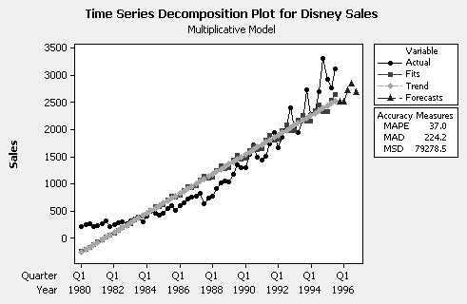

b. There is a significant trend but it is not a linear trend. First quarter sales
tend to be relatively low and third quarter sales tend to be relatively high.
However, the plot in part a indicates a multiplicative decomposition with a
linear trend is not an adequate representation of Disney sales. Perhaps
better to do a multiplicative decomposition with a quadratic trend. Even
better, in this case, is to do an additive decomposition with the logarithms
of Disney sales.

c. With the right decomposition, would use both the trend and seasonal
components to generate forecasts.

d. Forecasts

Quarter Forecast
Q4/1995 2506
Q1/1996 2502
Q2/1996 2719
Q3/1996 2830
Q4/1996 2681

However, the plot in part a indicates that forecasts generated from a multiplicative decomposition with a linear trend are likely to be too low.

17. a.
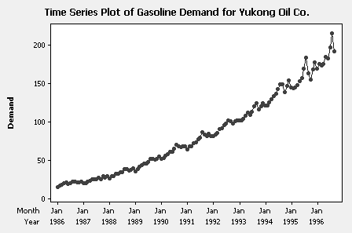

Variation appears to be increasing with level. Multiplicative
decomposition may be appropriate or additive decomposition with the
logarithms of demand.

b. Neither a multiplicative decomposition or an additive decomposition with a
linear trend work well for this series. This time series is best modeled with other methods. The multiplicative decomposition is pictured below.

c. Seasonal Indices (Multiplicative Decomposition for Demand)

Period Index Period Index Period Index
1 0.947 5 1.004 9 1.045
2 0.950 6 1.007 10 0.982
3 0.961 7 1.022 11 0.995
4 0.998 8 1.070 12 1.019

Demand tends to be relatively high in the late summer months.

d. Forecasts derived from a multiplicative decomposition of demand (see plot
below).

Month Forecast
Oct/1996 171.2
Nov/1996 174.9
Dec/1996 180.5

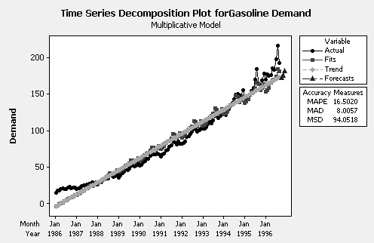

18. Multiplicative Model

Data U.S. Retail Sales
Length 84
NMissing 0

Fitted Trend Equation

Yt = 128.814 + 0.677*t

Seasonal Indices

Period Index
1 0.880
2 0.859
3 0.991
4 0.986
5 1.031
6 1.021
7 1.007
8 1.035
9 0.973
10 0.991
11 1.015
12 1.210

Forecasts and Actuals

Period Forecast Actual
Jan/1995 164.0 167.0
Feb/1995 160.7 164.0
Mar/1995 186.1 192.1
Apr/1995 185.8 187.5
May/1995 194.9 201.4
Jun/1995 193.6 202.6
Jul/1995 191.8 194.9
Aug/1995 197.7 204.2
Sep/1995 186.6 192.8
Oct/1995 190.6 194.0
Nov/1995 196.1 202.4
Dec/1995 234.5 238.0

Forecasts maintain the seasonal pattern but are uniformly below the actual
retail sales for 1995. However, MPE = MAPE = 2.49% is relatively small.
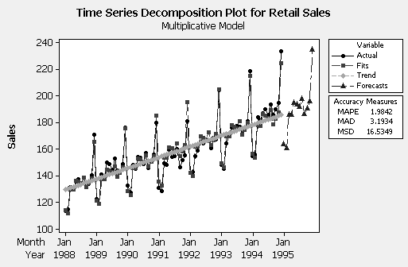

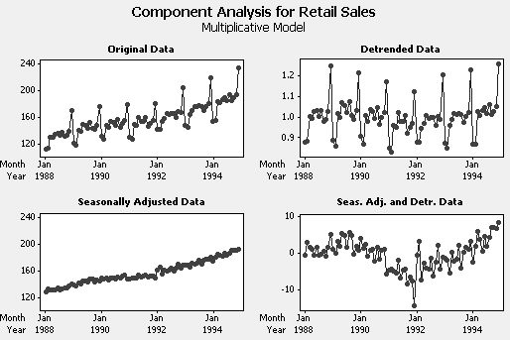

19. a. Jan = $\frac{\text{600}}{1\text{.}2}$= 500
500(1.37) = 685 people estimated for Feb

b. $\hat{T}$ = 140 + 5(t); t for Jan 2007 = 72
. $\hat{T}$ = 140 + 5(72) = 500

Jan $\hat{Y}$ = 500(1.20) = 600
Feb $\hat{Y}$= (140 + 5(73))(1.37) = 692
Mar $\hat{Y}$= (140 + 5(74))(1.00) = 510
Apr $\hat{Y}$= (140 + 5(75))(0.33) = 170
May $\hat{Y}$= (140 + 5(76))(0.47) = 244
Jun $\hat{Y}$= (140 + 5(77))(1.25) = 656
Jul $\hat{Y}$= (140 + 5(78))(1.53) = 811
Aug $\hat{Y}$= (140 + 5(79))(1.51) = 808
Sep $\hat{Y}$= (140 + 5(80))(0.95) = 513
Oct $\hat{Y}$= (140 + 5(81))(0.60) = 327
Nov $\hat{Y}$= (140 + 5(82))(0.82) = 451
Dec $\hat{Y}$= (140 + 5(83))(0.97) = 538

c. 5

22. Deflating a time series removes the effects of dollar inflation and permits the analyst
to examine the series in constant dollars.

23. 1289.73(2.847) = 3,671.86

24. Jan 303,589
Feb 251,254
Mar 303,556
Apr 317,872
May 329,551
Jun 261,362
Jul 336,417

25. Multiplicative Model

Data Employed Men
Length 130
NMissing 0

Fitted Trend Equation

Yt = 65355 + 72.7*t

Seasonal Indices

Month Index Month Index
1 0.981 7 1.019
2 0.985 8 1.014
3 0.990 9 1.002
4 0.995 10 1.004
5 1.002 11 0.999
6 1.014 12 0.995

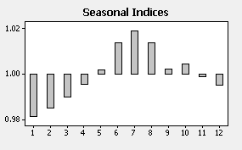

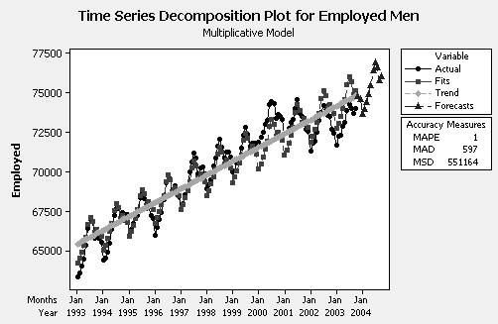

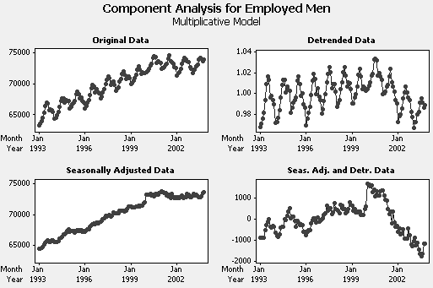

Forecasts

Month Forecast
Nov/2003 74791.4
Dec/2003 74581.7
Jan/2004 73607.8
Feb/2004 73954.0
Mar/2004 74393.4
Apr/2004 74887.2
May/2004 75454.0
Jun/2004 76419.5
Jul/2004 76894.1
Aug/2004 76564.4
Sep/2004 75757.2
Oct/2004 76005.6

A multiplicative decomposition with a default linear trend is not quite right for these
data. There is some curvature in the time series as the plot of the seasonally adjusted
data indicates. Not surprisingly, there is a strong seasonal component with
employment relatively high in the summer and relatively low in the winter. In spite
of the not quite linear trend, the forecasts seem reasonable.

26. A linear trend is not appropriate for the employed men data. The plot below shows
a quadratic trend fit to the data of Table P-25.

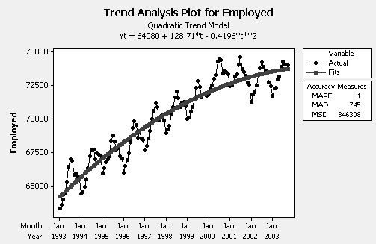

Although better than a linear trend, the quadratic trend is not quite right. Employment
for the years 2000—2003 seems to have leveled off. No simple trend curve is
likely to provide an excellent fit to these data. The residual autocorrelation
function below indicates a prominent seasonal component since there are large
autocorrelations at the seasonal lag S = 12 and its multiples.

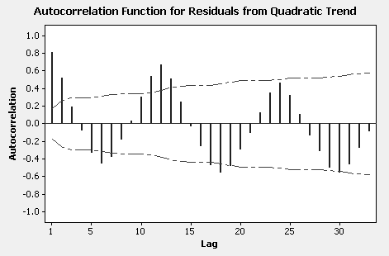

27. Multiplicative Model

Data Wal-Mart Sales
Length 56
NMissing 0

Fitted Trend Equation

Yt = 1157 + 1088*t

Seasonal Indices

Quarter Index
Q1 0.923
Q2 0.986
Q3 0.958
Q4 1.133

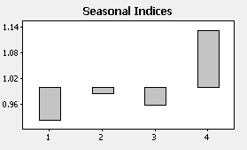

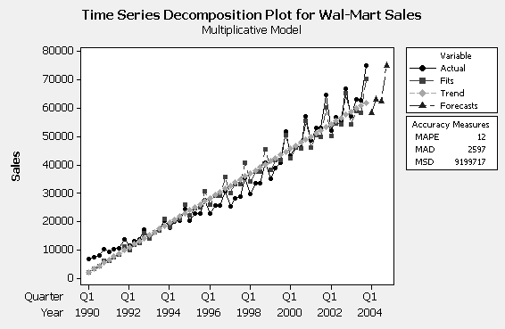

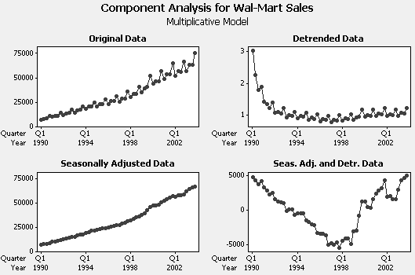

Forecasts and Actuals

Quarter Forecast Actuals
Q1/2004 58328 65443
Q2/2004 63346 70466
Q3/2004 62607 69261
Q4/2004 75278 82819

Slight upward curvature in the Wal-Mart sales data so a linear trend is not quite
right. Not surprisingly, there is a strong seasonal component with 4th quarter
sales relatively high and 1st quarter sales relatively low. The forecasts for 2004
are uniformly below the actuals (primarily the result of the linear trend assumption)
although the seasonal pattern is maintained. Here MPE = MAPE = 9.92%.
Multiplicative decomposition better than additive decomposition but any
decomposition that assumes a linear trend will not forecast sales for 2004 well.

28. A linear trend fit to the Wal-Mart sales data of Table P-27 is shown below. A
linear trend misses the upward curvature in the data.

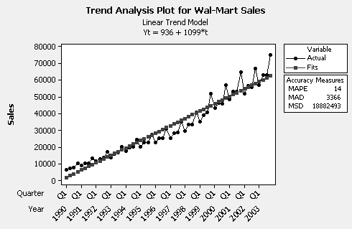

A quadratic trend provides a better fit to the Wal-Mart sales data (see plot
below). The autocorrelation function for the residuals from a quadratic
trend fit suggests a prominent seasonal component since there are large
autocorrelations at the seasonal lag S = 4 and its multiples.

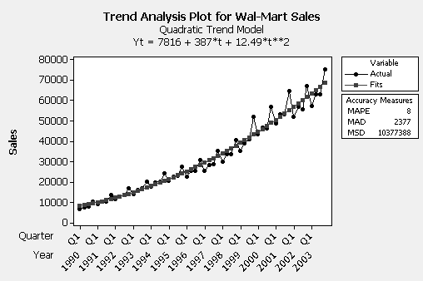

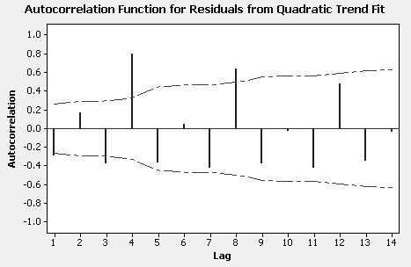

CASE 5-1: THE SMALL ENGINE DOCTOR

1.
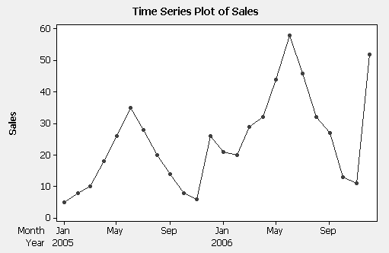

2.
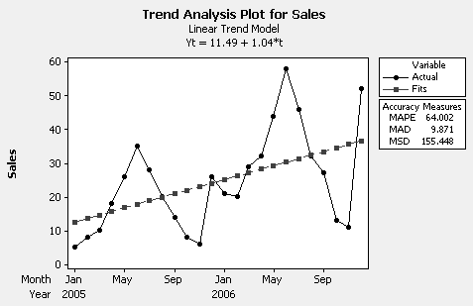

3. SEASONAL FITTED VALUES AND
ADJUSTMENT FORECASTS, T*S
MONTH FACTORS 2005 2006 2007

Jan 0.693 8.68 17.32 25.97
Feb 0.707 9.59 18.41 27.23
Mar 0.935 13.66 25.34 30.01
Apr 1.142 17.87 32.13 46.38
May 1.526 25.48 44.52 63.57
Jun 1.940 34.39 58.61 82.82
Jul 1.479 27.77 46.23 64.69
Aug 0.998 19.77 32.23 44.68
Sep 0.757 15.78 25.22 34.67
Oct 0.373 8.17 12.83 17.49
Nov 0.291 6.68 10.32 13.95
Dec 1.290 30.94 47.06 63.17

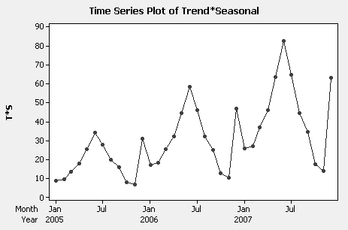

4.
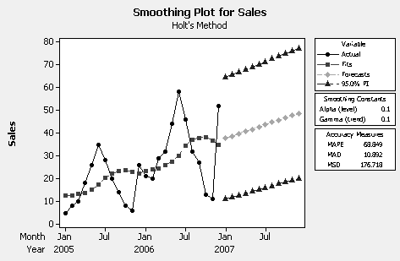

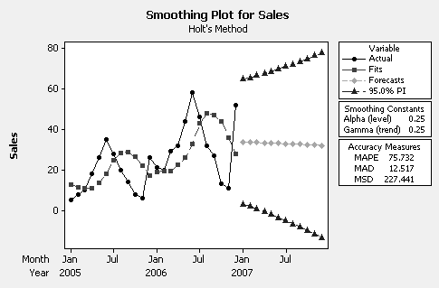

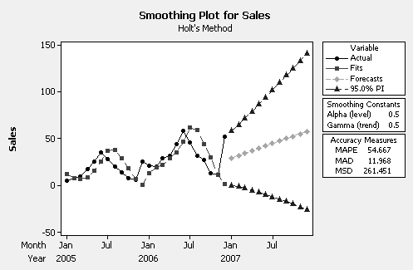

- Trend*Seasonality (T*S): MAD = 1.52
Linear Trend Model: MAD = 9.87

- If you had to limit your choices to the models in 2 and 4, the linear trend model is
better (judged by MAD and MSE) than any of the Holt smoothing procedures.
However, the Trend*Seasonality (T*S) model is best. This procedure is the only
one that takes account of the trend and seasonality in Small Engine Doctor sales.

CASE 5-2: MR. TUX

At last, John is able to deal directly with the strong seasonal effect in his monthly data. Students find it interesting that in addition to using these to forecast, John's banker wants them to justify variable loan payments.
To forecast using decomposition, students see that both the C and I components must be estimated. We like to emphasize that studying the C column in the computer printout is helpful, but that other study is needed to estimate the course of the economy over the next several months. The computer is not able to make such forecasts with accuracy, as anyone who follows economic news well knows.
Thinking about John’s efforts to balance his seasonal business to achieve a more uniform sales picture can generate a good class discussion. This is usually the goal of any business; examples such as boats/skis or bikes/skis illustrate this effort in many seasonal businesses. In fact, John Mosby put a great deal of effort into expanding his Seattle business in order to balance his seasonal effect. Along with his shirt making business, he has achieved a rather uniform monthly sales volume.

1. The two sentences might look something like this: A computer analysis of John
Mosby's monthly sales data clearly shows the strong variation by month. I think we are justified in letting him make variable monthly loan payments based on the seasonal
indices shown in the computer printout.

2. Since John expects to do twice as much business in Seattle as Spokane, the Seattle
indices he should try to achieve will be only half as far from 100 as the Spokane
indices, and on the opposite side of 100:
Spokane Seattle
Jan 31.4 134.3
Feb 47.2 126.4
Mar 88.8 105.6
Apr 177.9 61.1
May 191.8 54.1
Jun 118.6 90.7
Jul 102.9 98.6
Aug 128.7 85.7
Sep 93.8 103.1
Oct 81.5 109.3
Nov 60.4 119.8
Dec 77.1 111.5

3. Using the sales figures for January and February of 2005, to get “average” (100%) sales
dollars, divide the actual sales by the corresponding seasonal index:

Jan: 71,043/.314 = 226,252
Feb: 152,930/.472 = 324,004

Now subtract the actual sales from these target values to get the sales necessary
from the shirt making machine:

Jan: 226,252 - 71,043 = 155,209
Feb: 324,004 - 152,930 = 171,074

CASE 5-3: CONSUMER CREDIT COUNSELING

Both the trend and seasonal components are important. The trend explains about 34% percent of the total variance.

Multiplicative Model

Data Clients
Length 99

Fitted Trend Equation

Yt = 89.88 + 0.638*t

Seasonal Indices

Month Index
1 1.177
2 1.168
3 1.246
4 0.997
5 0.940
6 1.020
7 0.916
8 0.951
9 0.878
10 1.055
11 0.868
12 0.783

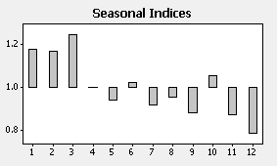

The number of new clients tends to be relatively large during the first three months
of the year.

Forecasts

Month Forecast
Apr/2003 153.207
May/2003 145.121
Jun/2003 158.062
Jul/2003 142.440
Aug/2003 148.560
Sep/2003 137.749
Oct/2003 166.161
Nov/2003 137.261
Dec/2003 124.277

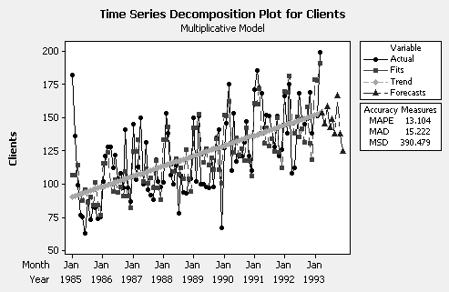

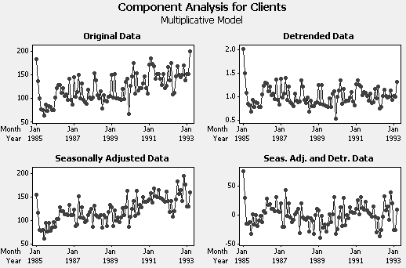

There is one, possibly two, large positive residuals (irregularities) at the beginning of the series but there are no significant residual autocorrelations.

CASE 5-4: MURPHY BROTHERS FURNITURE

1. An adequate model was found using Holt’s linear exponential smoothing.

Smoothing Constants

Alpha (level) 0.980
Gamma (trend) 0.025

Accuracy Measures

MAPE 1.1
MAD 76.2
MSD 11857.8

Forecasts

Month Forecast
Jan/2002 8127.8
Feb/2002 8165.1
Mar/2002 8202.4
Apr/2002 8239.7
May/2002 8277.0
Jun/2002 8314.2
Jul/2002 8351.5
Aug/2002 8388.8
Sep/2002 8426.1

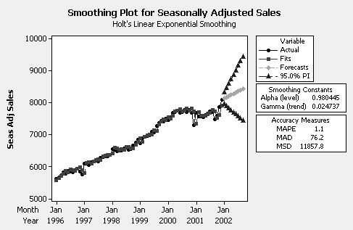

2. Forecasts and Actuals

Month Forecast Actual
Jan/2002 7453.2 7120
Feb/2002 7462.5 7124
Mar/2002 8058.7 7817
Apr/2002 7873.1 7538
May/2002 8223.5 7921
Jun/2002 8140.9 7757
Jul/2002 8308.8 7816
Aug/2002 8611.1 8208
Sep/2002 8368.2 7828

Holt’s linear smoothing was adequate for the seasonally adjusted data, but the
forecasts above are uniformly above the actual values for the first nine months of
2002.

3. Using the same procedure as in 2, the forecast for October, 2002 is 8609.2.

4. The pattern for the three sets of data shows a trend and monthly seasonality.

CASE 5-5: AAA WASHINGTON

1. An additive and a multiplicative decomposition perform equally well. The multiplicative
decomposition is shown below.

Multiplicative Model

Data Calls
Length 60
NMissing 0

Fitted Trend Equation

Yt = 21851 - 17.0437*t

Seasonal Indices

Month Index
1 0.937
2 0.922
3 0.972
4 0.963
5 0.925
6 1.016
7 1.063
8 1.094
9 1.094
11 1.025
12 0.936

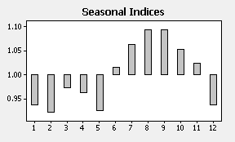

Accuracy Measures: MAPE 4 MAD 814 MSD 1276220

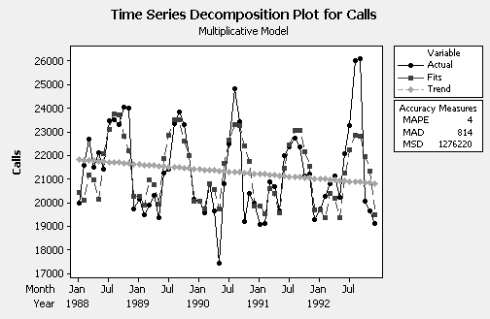

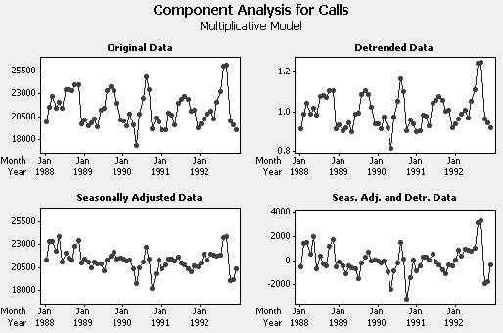

2. Decomposition analysis works pretty well for AAA Washington data. There is a
slight downward trend in emergency road service call volume with a pronounced
seasonal component. Volume tends to be relatively high in the summer and
early fall. There is significant residual autocorrelation at lag 1 (see plot below) so
not all the association in the data has been accounted for by the decomposition.

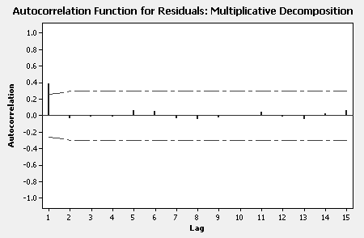

CASE 5-6: ALOMEGA FOOD STORES

The sales data for the Alomega Food Stores case is subjected to a multiplicative decomposition procedure in this case. A trend line is first calculated with the actual data plotted around it (using MINITAB). Students can project this line into future months for sales forecasts, although, as the case suggests, accurate forecasts will not result: The MAPE using only the trend line is 28%.
A plot of the seasonal indices from the MINITAB output is shown below.. Students can summarize the managerial benefits to Julie from studying these values. As noted in the case, the MAPE drops to 12% when the seasonal indices along with the trend are used.

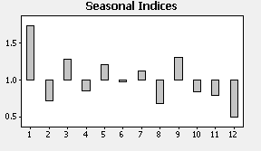

Finally, a 12-month forecast is generated using both the trend line and the seasonal indices. The forecasts seem reasonable.

Month Forecast
Jan/2007 785348
Feb/2007 326276
Mar/2007 585307
Apr/2007 391827
May/2007 558299
Jun/2007 453257
Jul/2007 520615
Aug/2007 319029
Sep/2007 614997
Oct/2007 394599
Nov/2007 377580
Dec/2007 235312

There are no significant residual autocorrelations.

Although more a management concern than a forecasting one, the attitude of Jackson Tilson in the case might generate a discussion that ties the computer assisted forecasting process into the real-life personalities of business associates. Although increasingly unlikely in the business setting, there are still those whose backgrounds do not include familiarity with computer based data analysis. Students whose careers will be spent in business might benefit from a discussion of the human element in the management process.
CASE 5-7: SURTIDO COOKIES

1. Multiplicative Model

Data SurtidoSales
Length 41
NMissing 0

Fitted Trend Equation

Yt = 907625 + 4736*t

Seasonal Indices

Month Index
1 0.696
2 0.546
3 0.517
4 0.678
5 0.658
6 0.615
7 0.716
8 0.567
9 1.527
10 1.664
11 1.988
12 1.829

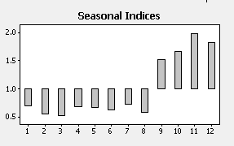

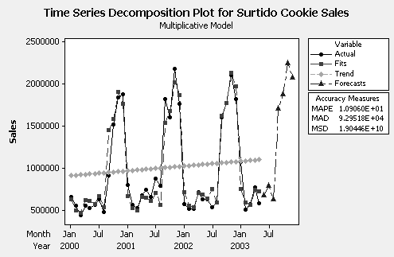

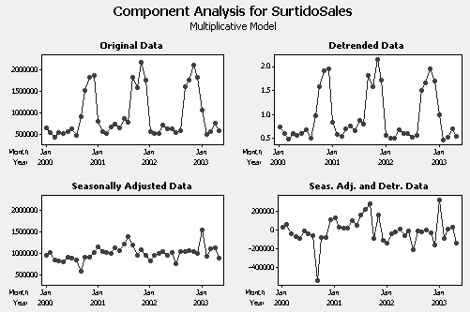

Month Forecast
Jun/2003 680763
Jul/2003 795362
Aug/2003 633209
Sep/2003 1710846
Oct/2003 1872289
Nov/2003 2246745
Dec/2003 2076183
2. The linear trend in sales has a slight upward slope. The seasonal indices show that
cookie sales are relatively high the last four months of the year with a peak in
November and relatively low the rest of the year.

3. The residual autocorrelation function is shown below. There are no significant
residual autocorrelations.

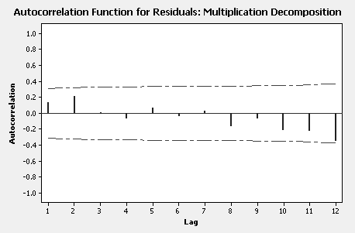

The multiplicative decomposition adequately accounts for the trend and seasonality
in the data. The forecasts are very reasonable. Jame should change his thinking
about the value of decomposition analysis.

CASE 5-8: SOUTHWEST MEDICAL CENTER

1. Decomposition of a time series involves isolating the underlying components
that make up the time series. These components are the trend or trend/cycle
(long term growth or decline), the seasonal (consistent within year variation
typically related to the calendar) and the irregular (unexplained variation).

2. The results and forecasts from a multiplicative decomposition and an additive
decomposition are nearly the same (apart from the seasonal indices being
either multiplicative or additive). For the purposes of this case, either
can be considered. The results from a multiplicative decomposition follow.

Multiplicative Model

Data Total Visits
Length 114
NMissing 0

Fitted Trend Equation

Yt = 955.6 + 4.02*t

Seasonal Indices

Month Index
1 0.972
2 1.039
3 0.943
4 0.884
5 1.039
6 0.935
7 1.043
8 1.033
9 0.995
10 1.007
11 1.091
12 1.019

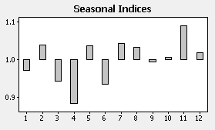

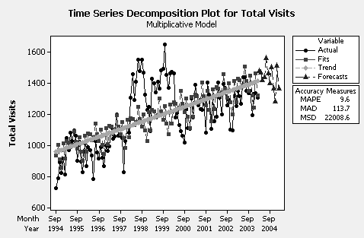

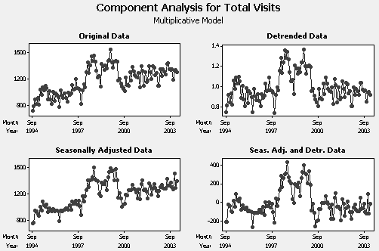

Forecasts

Month Forecast Month Forecast
Mar/2004 1479 Sep/2004 1401
Apr/2004 1469 Oct/2004 1502
May/2004 1419 Nov/2004 1367
Jun/2004 1440 Dec/2004 1284
Jul/2004 1564 Jan/2005 1514
Aug/2004 1464 Feb/2005 1367
3. There is a distinct upward trend in total visits. The seasonal indices show that
visits in December (4th month of fiscal year) tend to be relatively low and visits
in July (11th month of fiscal year) tend to be relatively high.

4. The residual autocorrelation function is shown below.

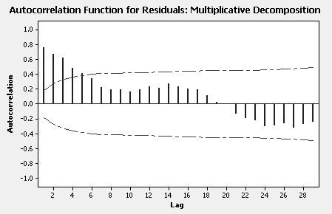

There are significant residual autocorrelations. The residuals are far from random
The forecasts may be reasonable given the last three fiscal years of data. However, looking at the time series decomposition plot in 2, it is clear a decomposition analysis
is not able to describe the middle two or three fiscal years of data. For some
reason, visits for these fiscal years, in general, appear to be unusually high. A
decomposition analysis does not adequately describe Mary’s data and leaves her
perplexed.

