CHAPTER 9

BOX-JENKINS (ARIMA) METHODOLOGY

ANSWERS TO PROBLEMS AND CASES

1. a. 0 ± .196

b. Series is random

c. Series could be a stationary autoregressive process or series could be non-stationary.
Interpretation depends on how fast the autocorrelations decay to 0.

d. Seasonal series with period of 4

2. t Y_{t} ${\hat{Y}}_{t}$ e_{t}
1 32.5 35.000 -2.500
2 36.6 34.375 2.225
3 33.3 36.306 -3.006
4 31.9 33.581 -1.681

$\hat{Y}$₅ = 35 + .25(-1.681) - .3(-3.006) = 35.482
$\hat{Y}$₆ = 35 + .25(0) - .3(-1.681) = 35.504
$\hat{Y}$₇ = 35

3. a. ${\hat{Y}}_{\text{61}}$ = 75.65 ${\hat{Y}}_{\text{62}}$ = 84.04 ${\hat{Y}}_{\text{63}}$ = 87.82

b. ${\hat{Y}}_{\text{62}}$ = 76.55 ${\hat{Y}}_{\text{63}}$ = 84.45

c. 75.65 ± 2√3.2

4. a. Model Autocorrelations Partial Autocorrelations
AR die out cut off
MA cut off die out
ARIMA die out die out
5. a. MA(2)
b. AR(1)
c. ARIMA(1,0,1)

6. a. Model is not adequate.

b. Q = 44.3 df = 11 α = .05
Reject H₀ if $χ^{2}$ > 19.675
Since Q = 44.3 > 19.675, reject H₀ and conclude model is not adequate. Also,
there is a significant residual autocorrelation at lag 2. Add a MA term to the
model at lag 2 and fit an ARIMA(1,1,2) model.

7. a. Autocorrelations of original series fail to die out, suggesting that demand is
non-stationary. Autocorrelations for first differences of demand, do die
out (cut off relative to standard error limits) suggesting series of first
differences is stationary. Low lag autocorrelations of series of second
differences increase in magnitude, suggesting second differencing is too
much. A plot of the demand series shows the series is increasing linearly in
time with almost a perfect (deterministic) straight line pattern. In fact, a
straight line time trend fit to the demand data represents the data well as
shown in the plot below.
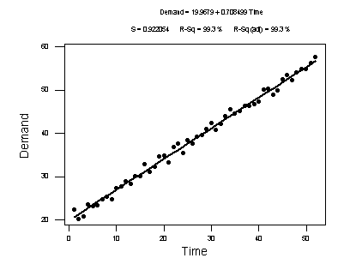
If an ARIMA model is fit to the demand data, the autocorrelations and
plots of the original series and the series of first differences, suggest an
ARIMA(0,1,1) model with a constant term might be good starting point. The
first order moving average term is suggested by the significant autocorrelation
at lag 1 for the first differenced series.

b. The Minitab output from fitting an ARIMA(0,1,1) model with a constant is
shown below.

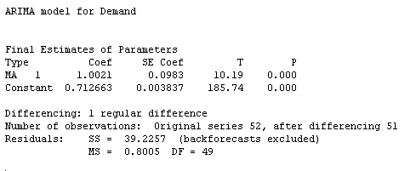
The least squares estimate of the constant term, .7127, is virtually the same as
The least squares slope coefficient in the straight line fit shown in part a. Also,
The first order moving average coefficient is essentially 1. These two results
are consistent with a straight line time trend regression model for the original data.

Suppose $Y_{t}$ is demand in time period t. The straight line time trend regression
model is: $Y_{t}=β_{0}+β_{1}t+ε_{t}$. Thus $Y_{t−1}=β_{0}+β_{1}(t−1)+ε_{t−1}$ and
$Y_{t}−Y_{t−1}=β_{1}+ε_{t}−ε_{t−1}$. The latter is an ARIMA(0,1,1) model with a constant
term (the slope coefficient in the straight line model) and a first order moving
average coefficient of 1.

There is some residual autocorrelation (particularly at lag 2) for both the straight
line fit and the ARIMA(0,1,1) fit, but the usual residual plots indicate no other
problems.

c. Prediction equations for period 53.
Straight line model: ${\hat{Y}}_{\text{53}}=\text{19}\text{.}\text{97}+\text{.}\text{71}(\text{53})$
ARIMA model: ${{\hat{Y}}_{\text{53}}=Y_{\text{52}}+\text{.}\text{71}−1\text{.}\text{00 \{}\hat{ε}}_{\text{52}}$

d. The forecasts for the next four periods from forecast origin t = 52 for the
ARIMA model follow.
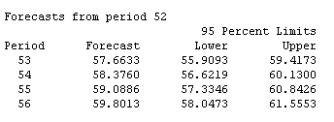
These forecasts are essentially the same as the forecasts obtained by
extrapolating the fitted straight line in part a.

8. Since the autocorrelation coefficients drop off after one time lag and the partial
autocorrelation coefficients trail off, an MA(1) model should be adequate. The best
model is

$\hat{Y}$_{t} = 56.1853 - (-0.7064)ε_{t-1}

The forecast for period 127 is

$\hat{Y}$₁₂₇ = 56.1853 + 0.7064)ε₁₂₅

$\hat{Y}$₁₂₇ = 56.1853 + 0.7064)(-5.4) = 52.37

The critical 5% chi-square value for 10 df is 18.31. Since the calculated chi-square
Q for the residual autocorrelations equals 7.4, the model is deemed adequate.

The autocorrelation and partial autocorrelation plots for the original series follow.
ARIMA model for Yt
Final Estimates of Parameters
Type Coef StDev T
MA 1 -0.7064 0.0638 -11.07
Constant 56.1853 0.5951 94.42
Mean 56.1853 0.5951

Number of observations: 126
Residuals: SS = 1910.10 (backforecasts excluded)
MS = 15.40 DF = 124
Modified Box-Pierce (Ljung-Box) Chi-Square statistic
Lag 12 24 36 48
Chi-Square 7.4(DF=10) 36.4(DF=22) 64.8(DF=34) 80.5(DF=46)

95 Percent Limits
Period Forecast Lower Upper
127 52.3696 44.6754 60.0637
128 56.1853 46.7651 65.6054
129 56.1853 46.7651 65.6054

9. Since the autocorrelation coefficients trail off and the partial autocorrelation
coefficients cut off after one time lag, an AR(1) model should be adequate.
The best model is

$\hat{Y}$_{t} = 109.628 - 0.9377Y_{t-1}

The forecast for period 81 is

$\hat{Y}$₈₁ = 109.628 - 0.9377Y₈₀

$\hat{Y}$₈₁ = 109.628 - 0.9377(85) = 29.92

ARIMA model for Yt
Final Estimates of Parameters
Type Coef StDev T
AR 1 -0.9377 0.0489 -19.17
Constant 109.628 0.611 179.57
Mean 56.5763 0.3151

Number of observations: 80
Residuals: SS = 2325.19 (backforecasts excluded)
MS = 29.81 DF = 78
Modified Box-Pierce (Ljung-Box) Chi-Square statistic
Lag 12 24 36 48
Chi-Square 24.8(DF=10) 39.4(DF=22) 74.0(DF=34) 83.9(DF=46)

95 Percent Limits
Period Forecast Lower Upper
81 29.9234 19.2199 40.6269
82 81.5688 66.8957 96.2419
83 33.1408 15.7088 50.5728

The critical 5% chi-square value for 10 df's is 18.31. Since the calculated chi-square
Q for the residual autocorrelations equals 24.8, the model is deemed inadequate. An
examination of the individual residual autocorrelations suggests it might be possible to
improve the model by adding a MA term at lag 2.

10. As can be seen below, the autocorrelations for the original series are slow to die out. This
behavior indicates the series may be non-stationary. The autocorrelations for the
differenced data cut off after lag 1 and the partial autocorrelations die out. This suggests
an ARIMA(0,1,1) model. When this model is fit (see the computer output below), there
are no significant residual autocorrelations and the residual plots look good. The
forecasting equation from the fitted model is

$\hat{Y}$_{t} = Y_{t-1} - (-0.3714)ε_{t-1}

The forecast for period 81 is

$\hat{Y}$₈₁ = Y₈₀ - (-0.3714)ε₈₀
$\hat{Y}$₈₁ = 266.9 - (-0.3714)(3.4647) = 268.19

ARIMA model for Yt
Final Estimates of Parameters
Type Coef StDev T
MA 1 -0.3714 0.1052 -3.53

Differencing: 1 regular difference
Number of observations: Original series 80, after differencing 79
Residuals: SS = 10637.3 (backforecasts excluded)
MS = 136.4 DF = 78
Modified Box-Pierce (Ljung-Box) Chi-Square statistic
Lag 12 24 36 48
Chi-Square 9.2(DF=11) 14.1(DF=23) 28.6(DF=35) 39.2(DF=47)

95 Percent Limits
Period Forecast Lower Upper
81 268.741 245.848 291.635
82 268.741 229.885 307.597
83 268.741 218.787 318.695

The critical 5% chi-square value for 11 df's is 19.68. Since the calculated
chi-square Q for the residual autocorrelations equals 9.2, the model is deemed adequate.

11. The slow decline in the early, non-seasonal lags indicates the need for regular
differencing.

The peaks at lags 12 and 24 are apparent. The seasonal autocorrelation
coefficients seem to be decaying slowly. Seasonal differencing is necessary.
The autocorrelation coefficient and partial autocorrelation coefficient plots for the
regular and seasonal differenced data are shown on the next page.

Concentrating on the non-seasonal lags, the autocorrelation coefficients drop off
after one time lag and the partial autocorrelation coefficients trail off, so a regular
moving average term of order 1 is indicated. Concentrating on the seasonal lags
(12 and 24), the autocorrelation coefficients cut off after lag 12 and the partial
autocorrelation coefficients trail off, so a seasonal moving average term of order 12
is suggested. An ARIMA(0,1,1)(0,1,1) model for Yt is identified.

Final Estimates of Parameters
Type Coef StDev T
MA 1 0.7486 0.0742 10.09
SMA 12 0.8800 0.0893 9.85

Differencing: 1 regular, 1 seasonal of order 12
Number of observations: Original series 96, after differencing 83
Residuals: SS = 5744406210 (backforecasts excluded)
MS = 70918595 DF = 81

Modified Box-Pierce (Ljung-Box) Chi-Square statistic
Lag 12 24 36 48
Chi-Square 3.0(DF=10) 19.3(DF=22) 23.0(DF=34) 25.1(DF=46)

95 Percent Limits
Period Forecast Lower Upper
97 163500 146991 180009
98 158300 141277 175322
99 177084 159562 194606
100 178792 160785 196798
101 188706 170227 207185
102 184846 165907 203785
103 191921 172532 211310
104 188746 168918 208574
105 185194 164936 205451
106 187669 166991 208348
107 188084 166993 209175
108 221521 200025 243016

The critical 5% chi-square value for 10 df's is 18.31. Since the calculated
chi-square Q for the residual autocorrelations equals 3, the model is deemed adequate.

12. a. See part b.

b. The autocorrelation coefficient plot below indicates that the data are
non-stationary. Therefore, the data should be first differenced. The
autocorrelation coefficient and partial autocorrelation coefficient plots for
the first differenced data are also shown.
c. There is not much going on in either the autocorrelations or partial autocorrelations
for the differenced series. Could make a case for a first order AR term in a model
for the differenced data. The results from fitting an ARIMA(0,1,1) model are shown
below. Successive changes are not random if an ARIMA(0,1,1) model is appropriate.

ARIMA model for IBM

Final Estimates of Parameters
Type Coef StDev T P
AR 1 0.3780 0.1496 2.53 .015

Differencing: 1 regular difference
Number of observations: Original series 52, after differencing 51
Residuals: SS = 1710.50 (backforecasts excluded)
MS = 34.21 DF = 50

Modified Box-Pierce (Ljung-Box) Chi-Square statistic
Lag 12 24 36 48
Chi-Square 7.3(DF=11) 15.8(DF=23) 28.5(DF=35) 38.1(DF=47)

95 Percent Limits
Period Forecast Lower Upper
53 311.560 300.094 323.026
54 314.418 294.895 333.941

d. The residual plots look good and there are no significant residual autocorrelations.
There is no reason to doubt the adequacy of the model.

e. $\hat{Y}$_{t} = Y_{t-1} + .378(Y_{t} - Y_{t-1})

$\hat{Y}$₅₃ = Y₅₂ + .378(Y₅₃ - Y₅₂)

$\hat{Y}$₅₃ = 304 + .378(304 - 284) = 311.56
The naïve forecast is ${\hat{Y}}_{\text{53}}=Y_{\text{52}}=\text{304}$.

13. One question that might arise is should the student use the first 145 observations or
all 150 observations. With this many observations, it will not make much difference.
The autocorrelation function using all the data below is slow to die out and suggests
the DEF time series is non-stationary. Therefore, the differenced data should be investigated.

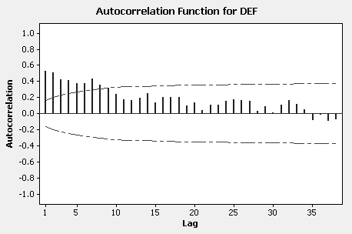

The autocorrelation coefficient and partial autocorrelation coefficient plots for the first
differenced data follow.

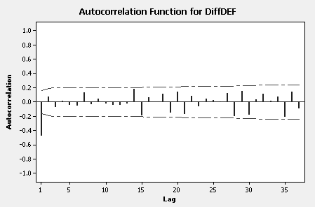

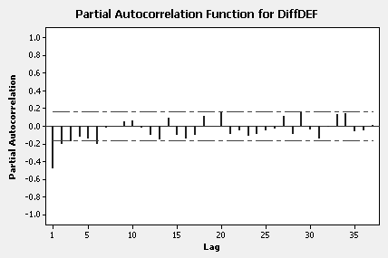

It appears that the autocorrelations for the differenced data cut off after lag one
and that the partial autocorrelations die out. This suggests a regular MA term in a model
for the differenced data so an ARIMA(0,1,1) model is identified. If 145 observations
are used, the forecasting equation from the fitted model is

$\hat{Y}$_{t} = Y_{t-1} - 0.7179ε_{t-1}

The computer output for the fitted model is given below.

Final Estimates of Parameters

Type Coef SE Coef T P
MA 1 0.7179 0.0582 12.34 0.000
Constant -0.00049 0.06024 -0.01 0.994

Differencing: 1 regular difference
Number of observations: Original series 145, after differencing 144
Residuals: SS = 917.134 (backforecasts excluded)
MS = 6.459 DF = 142

Modified Box-Pierce (Ljung-Box) Chi-Square statistic

Lag 12 24 36 48
Chi-Square 12.3 29.5 57.2 66.1
DF 10 22 34 46
P-Value 0.266 0.131 0.008 0.028

Forecasts from period 145

95% Limits
Period Forecast Lower Upper Actual
146 133.815 128.832 138.797 135.2
147 133.814 128.637 138.991 139.2
148 133.814 128.450 139.178 136.8
149 133.813 128.268 139.358 136.0
150 133.813 128.092 139.533 134.4

This model fits well. The usual residual analysis indicates no model inadequacies.

Comparing the forecasts with the actuals for the five days from forecast origin t = 145
using MAPE gives MAPE = 1.82%.

14. The time series plot follows.

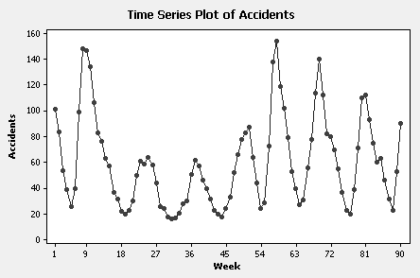

The sample autocorrelation and partial autocorrelation functions below suggest and
AR(2) or, equivalently, an ARIMA(2,0,0) model. The computer output follows along
with the residual autocorrelation function.

Final Estimates of Parameters

Type Coef SE Coef T P
AR 1 1.4837 0.0732 20.26 0.000
AR 2 -0.7619 0.0729 -10.45 0.000
Constant 17.181 1.381 12.44 0.000
Mean 61.757 4.965

Number of observations: 90
Residuals: SS = 14914.5 (backforecasts excluded)
MS = 171.4 DF = 87

Modified Box-Pierce (Ljung-Box) Chi-Square statistic

Lag 12 24 36 48
Chi-Square 19.9 25.9 41.7 55.9
DF 9 21 33 45
P-Value 0.018 0.209 0.142 0.128

Forecasts from period 90

95% Limits
Period Forecast Lower Upper Actual
91 110.333 84.665 136.001

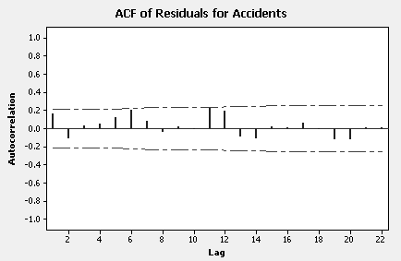

The forecast of 110 accidents for the 91st week seems reasonable given the history
of the series near that point.

There is no evidence of annual seasonality in these data but since there is less
than two years of weekly observations, seasonality, if it exists, would be virtually
impossible to detect.

15. The time series plot that follows suggests the Price series is non-stationary. This
is corroborated by the autocorrelations which are slow to die out. The differenced
series should be investigated.

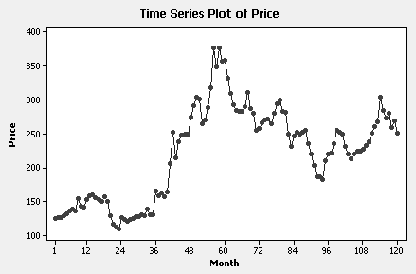

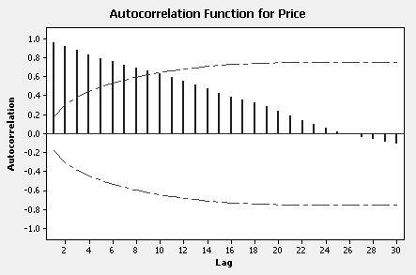

The autocorrelation function for the differenced data below suggests the
differenced series is random. The partial autocorrelation function for the
differenced data has a similar appearance.

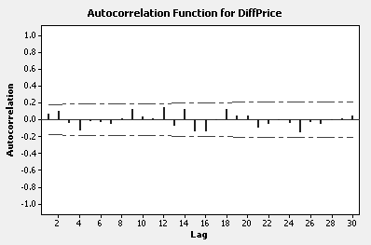

An ARIMA(0,1,0) model is identified for the price of corn. For this model
a forecast of the next observation at forecast origin t is given by ${\hat{Y}}_{t+1}=Y_{t}$. Forecasts
two steps ahead are the same, similarly for three steps ahead and so forth. In other
words, this model produces “flat line” forecasts whose intercept is given by $Y_{t}$.
So, forecasts of the price of corn for the next 12 months are all given by the last
observation or 251 cents per bushel.

16. The variation in the Cavanaugh sales series increases with the level, so a log
transformation seems appropriate. Let $Y_{t}$ be the natural log of sales and
$W_{t}=Y_{t}−Y_{t−\text{12}}$ be the seasonally differenced series. Two ARIMA models that
represent the data reasonably well are given by the expressions
ARIMA(0,0,2)(0,1,0)₁₂ and ARIMA(1,0,0)(0,1,1)₁₂. Both models contain a
constant term. Another possibility is the ARIMA(0,1,1)(0,1,1)₁₂ model (without
a constant), but the latter doesn’t fit quite as well as the former models. The results
for the ARIMA(1,0,0)(0,1,1)₁₂ process are displayed below.

Fitted model: $W_{t}=\text{.}\text{54}W_{t−1}+\text{.}\text{119}+ε_{t}−\text{.}\text{81}ε_{t−\text{12}}$

Final Estimates of Parameters
Type Coef SE Coef T P
AR 1 0.5400 0.1080 5.00 0.000
SMA 12 0.8076 0.1162 6.95 0.000
Constant 0.1187 0.0060 19.70 0.000
Differencing: 0 regular, 1 seasonal of order 12
Number of observations: Original series 77, after differencing 65

Forecasts: Date ForecastLnSales ForecastSales

Jun. 2000 5.76675 320
Jul. 2000 6.11484 453
Aug. 2000 6.40039 602
Sep. 2000 6.80928 906
Oct. 2000 7.09153 1202
Nov. 2000 7.14969 1274
Dec. 2000 6.85211 946

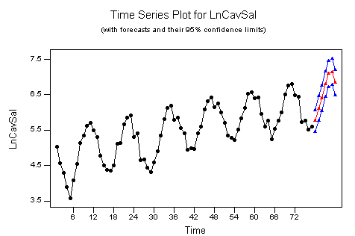

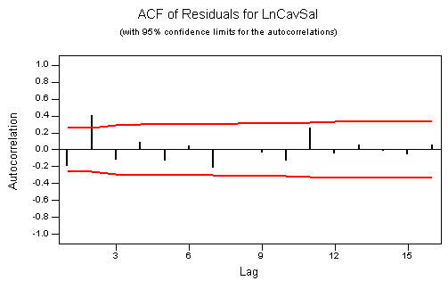

The residual autocorrelation a lag 2 can be ignored or, alternatively, can fit the
ARIMA(0,0,2)(0,1,1)₁₂ model.

17. The variation in Disney sales increases with the level, so a log transformation
seems appropriate. Let $Y_{t}$ be the natural log of sales and $W_{t}=Y_{t}−Y_{t−4}$ be the
seasonally differenced series. Two ARIMA models that represent the data
reasonably well are given by the representations ARIMA(1,0,0)(0,1,1)₄ and
ARIMA(0,1,1)(0,1,1)₄. The former model contains a constant. The results for
the ARIMA(1,0,0)(0,1,1)₄ process are displayed below.

Fitted model: $W_{t}=\text{.}\text{50}W_{t−1}+\text{.}\text{089}+ε_{t}−\text{.}\text{49}ε_{t−4}$

Final Estimates of Parameters
Type Coef SE Coef T P

AR 1 0.4991 0.1164 4.29 0.000
SMA 4 0.4863 0.1196 4.07 0.000
Constant 0.0886 0.0063 14.07 0.000
Differencing: 0 regular, 1 seasonal of order 4
Number of observations: Original series 63, after differencing 59

Forecasts: Date ForecastLnSales ForecastSales
Q4 1995 8.25008 3828
Q1 1996 8.12423 3375
Q2 1996 8.11642 3349
Q3 1996 8.24372 3804
Q4 1996 8.43698 4615

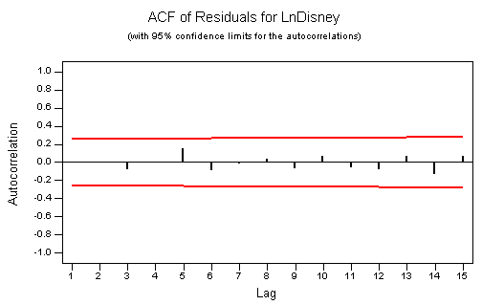

18. The data were transformed by taking natural logs; however, an ARIMA model
may be fit to the original observations. Let $Y_{t}$ be the natural log of demand
and let $W_{t}={\text{ΔΔ}}_{\text{12}}Y_{t}=Y_{t}−Y_{t−1}−Y_{t−\text{12}}+Y_{t−\text{13}}$ be the series after taking one seasonal
difference followed by a regular difference. An ARIMA(0,1,1)(0,1,1)₁₂ model
represents the log demand series well. The results follow.

Fitted model: $W_{t}=ε_{t}−\text{.}\text{63}ε_{t−1}−\text{.}\text{57}ε_{t−\text{12}}+(\text{.}\text{63})(\text{.}\text{57})ε_{t−\text{13}}$

Final Estimates of Parameters
Type Coef SE Coef T P
MA 1 0.6309 0.0724 8.71 0.000
SMA 12 0.5735 0.0849 6.75 0.000
Differencing: 1 regular, 1 seasonal of order 12
Number of observations: Original series 129, after differencing 116

Forecasts: Date ForecastLnDemand ForecastDemand
Oct. 1996 5.23761 188
Nov. 1996 5.29666 200
Dec. 1996 5.33704 208

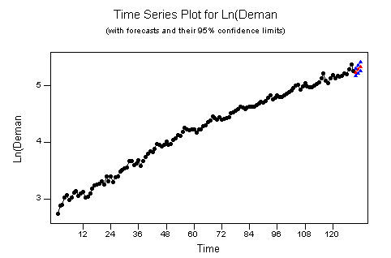

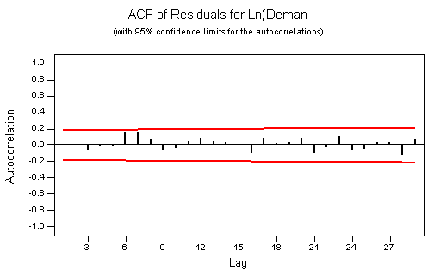

19. Let $W_{t}={\text{ΔΔ}}_{\text{12}}Y_{t}=Y_{t}−Y_{t−1}−Y_{t−\text{12}}+Y_{t−\text{13}}$ be the series after taking one seasonal
difference followed by a regular difference. Examination of the autocorrelation
function for $W_{t}$ leads to the identification of an ARIMA(0,1,0)(0,1,1)₁₂ model.
The results follow.

Fitted model: $W_{t}=ε_{t}−\text{.}\text{84}ε_{t−\text{12}}$

Final Estimates of Parameters
Type Coef SE Coef T P
SMA 12 0.8438 0.0733 11.51 0.000
Differencing: 1 regular, 1 seasonal of order 12
Number of observations: Original series 130, after differencing 117

Residuals: SS = 7165296 (backforecasts excluded)
MS = 61770 DF = 116

Modified Box-Pierce (Ljung-Box) Chi-Square statistic

Lag 12 24 36 48
Chi-Square 13.2 19.3 26.2 52.6
DF 11 23 35 47
P-Value 0.280 0.681 0.858 0.266

Forecasts from period 130

95% Limits
Period Forecast Lower Upper
131 73653.4 73166.1 74140.6
132 73448.7 72759.7 74137.8
133 72571.8 71727.9 73415.7
134 72904.3 71929.8 73878.7
135 73200.8 72111.4 74290.3
136 73711.5 72518.1 74905.0
137 74218.7 72929.6 75507.7
138 75021.6 73643.5 76399.7
139 75459.7 73998.0 76921.4
140 75114.5 73573.8 76655.3
141 74519.0 72903.0 76134.9
142 74681.4 72993.6 76369.2

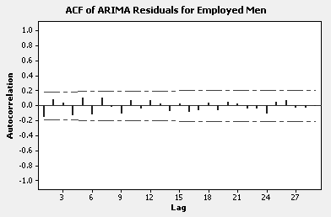

20. The variation in Wal-Mart sales increases with the level, so a log transformation
seems appropriate. Let $Y_{t}$ be the natural log of sales and $W_{t}=Y_{t}−Y_{t−4}$ be the
seasonally differenced series. Examination of the autocorrelation function for $W_{t}$
leads to the identification of an ARIMA(0,1,0)(0,1,1)₄ model.
The results follow.

Fitted model: $W_{t}=ε_{t}−\text{.}\text{52}ε_{t−4}$

Final Estimates of Parameters
Type Coef SE Coef T P
SMA 4 0.5249 0.1185 4.43 0.000
Differencing: 1 regular, 1 seasonal of order 4
Number of observations: Original series 60, after differencing 55

Residuals: SS = 0.0323112 (backforecasts excluded)
MS = 0.0005984 DF = 54

Modified Box-Pierce (Ljung-Box) Chi-Square statistic

Lag 12 24 36 48
Chi-Square 12.5 20.3 30.3 47.7
DF 11 23 35 47
P-Value 0.327 0.626 0.697 0.445

Forecasts from period 60

Forecasts
Period LnSales Sales
Q1/05 11.1671 70,764
Q2/05 11.2514 76,988
Q3/05 11.2408 76,176
Q4/05 11.4233 91,427
Q1/06 11.2660 78,120
Q2/06 11.3503 84,991
Q3/06 11.3397 84,095
Q4/06 11.5223 100,942

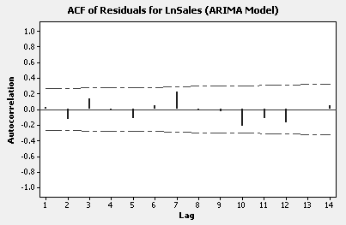
21. Autocorrelations and partial autocorrelations for number of severe earthquakes suggest
an AR(1) model.

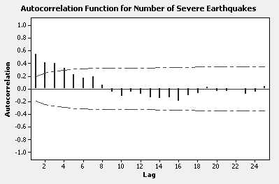

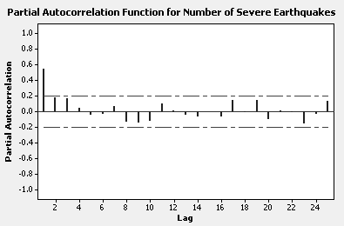

Summary of model fit and forecasts for the next 5 years follow.

Final Estimates of Parameters
Type Coef SE Coef T P
AR 1 0.5486 0.0845 6.49 0.000
Constant 9.0295 0.6082 14.85 0.000
Mean 20.001 1.347
Number of observations: 100

Residuals: SS = 3624.87 (backforecasts excluded)
MS = 36.99 DF = 98

Modified Box-Pierce (Ljung-Box) Chi-Square statistic

Lag 12 24 36 48
Chi-Square 11.0 23.2 30.7 45.9
DF 10 22 34 46
P-Value 0.358 0.388 0.631 0.477

Forecasts from period 100

95% Limits
Period Forecast Lower Upper
101 21.6463 9.7236 33.5691
102 20.9037 7.3049 34.5026
103 20.4964 6.4323 34.5605
104 20.2729 6.0718 34.4741
105 20.1504 5.9082 34.3925
106 20.0831 5.8287 34.3376

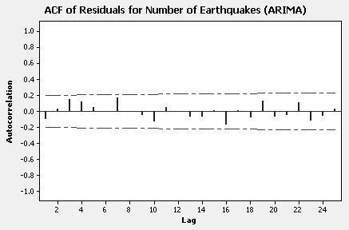

22. Since the variation in the series increases with the level, a log transformation is indicated.
An examination of the autocorrelations and partial autocorrelations for LnGapSales leads
to the identification of an ARIMA(0,1,0)(0,1,1)₄ model. Summary of model fit and
forecasts for the next 8 quarters follow.

Final Estimates of Parameters
Type Coef SE Coef T P
SMA 4 0.2780 0.1004 2.77 0.007
Differencing: 1 regular, 1 seasonal of order 4
Number of observations: Original series 100, after differencing 95

Residuals: SS = 0.311695 (backforecasts excluded)
MS = 0.003316 DF = 94

Modified Box-Pierce (Ljung-Box) Chi-Square statistic

Lag 12 24 36 48
Chi-Square 14.8 19.7 24.2 27.3
DF 11 23 35 47
P-Value 0.194 0.659 0.916 0.990

Forecasts from period 100

Period LnGapSales GapSales
101 8.19679 3,629
102 8.23373 3,766
103 8.30268 4,035
104 8.51475 4,988
105 8.21496 3,696
106 8.25189 3,835
107 8.32085 4,109
108 8.53291 5,079

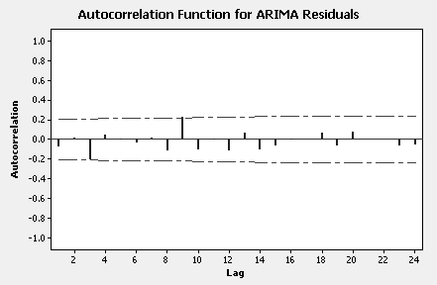

23. The long strings of 0’s (no Influenza A positive cases) of uneven lengths might create
identification and fitting problems for ARIMA modeling. On the other hand, a simple
AR(1) model with an AR coefficient of about .8 and no constant term might provide
reasonable one week ahead forecasts for the number of positive cases. These forecasts
can be generated with the understanding that any non-integer forecast less than 1 is set
to 0 and any non-integer forecast greater than 1 is rounded to the closest integer.

CASE 9-1: RESTAURANT SALES

1. & 2. & 3. AR(1) model is appropriate. See summary, forecasts and actuals below.

Final Estimates of Parameters

Type Coef SE Coef T P
AR 1 0.5997 0.0817 7.34 0.000
Constant 1921.7 100.2 19.18 0.000
Mean 4800.8 250.3

Number of observations: 104

Residuals: SS = 105964742 (backforecasts excluded)
MS = 1038870 DF = 102

Modified Box-Pierce (Ljung-Box) Chi-Square statistic

Lag 12 24 36 48
Chi-Square 8.9 24.5 36.8 48.5
DF 10 22 34 46
P-Value 0.545 0.322 0.342 0.372

Forecasts and actuals for first four weeks in January 1983:

95% Limits
Period Forecast Lower Upper Actual
105 3249.49 1251.36 5247.62 2431
106 3870.48 1540.58 6200.38 2796
107 4242.89 1804.68 6681.10 4432
108 4466.23 1990.23 6942.23 5714

Forecasts are too high for first two weeks of January 1983 and too low for next
Two weeks. Note however, that actual sales fall within the 95% prediction
interal limits for each of the four weeks.

4. The best model in Chapter 8 for the original Restaurant Sales data is an autoregressive
model with an added dummy variable to represent the period during the year when
Marquette University is in session. So, because of the additional dummy variable, this
model fits the data better than the AR(1) model in part 1. If the dummy variable were not
present, the two models would be the same. Consequently, we would expect better
forecasts with the AR + dummy variable model than with the simple AR model.
Regardless, however, if forecasts are compared to actuals from forecast origin 104 (last
week in 1982), the usual measures of forecast accuracy (RMSE, MAPE, etc.) are likely
to be relatively large since a large portion of the variation in sales is not accounted for
by the AR + dummy variable model.
5. At the very least the parameters in the AR(1) model should be re-estimated if the
new data are combined with the old data. A better approach is to combine the data
and the go through the usual ARIMA model building process again. It may be the
combined data suggest the form of the ARIMA has changed. In this case, an AR(1)
is still appropriate when the new data are combined with the old data.

CASE 9-2: MR. TUX

1. Box-Jenkins ARIMA models account for the autocorrelation in the observed series using
possibly differenced data, lagged dependent variables and current and previous errors.
There are no potential causal (exogenous) independent variables in these models so they
are often difficult to explain to management. Best to demonstrate the results.

2. Autocorrelation and partial autocorrelation plots for the regular and seasonally
differenced data suggest a non-seasonal AR(2) term (the partial autocorrelations cut
off after lag 2 and the autocorrelations die out). No seasonal MA or AR terms should
be included. However, here is a case where, say, the ARIMA(2, 1, 0)(0, 1, 0)₁₂
model is more complex than necessary and a much simpler model works well. A time
series plot of the seasonally differenced Mr. Tux data is shown below along with the
sample autocorrelation function for these differences.

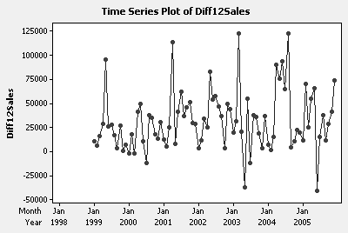

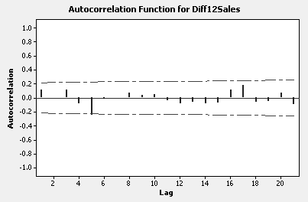

It is evident an ARIMA(0, 0, 0)(0, 1, 0)₁₂ model of the form $Y_{t}−Y_{t−\text{12}}=ω_{0}+ε_{t}$ might
provide a good fit to the Mr. Tux data.

3. To fit the model $W_{t}=Y_{t}−Y_{t−\text{12}}=ω_{0}+ε_{t}$ to the Mr. Tux data, simply set ${\hat{ω}}_{0}=\bar{W}$, the
mean of the seasonal differences. Here ${\hat{ω}}_{0}=\text{32},\text{174}$. Since the residuals from this model differ from the seasonal differences by the constant ${\hat{ω}}_{0}=\text{32},\text{174}$, the residual autocorrelation function will be identical to the autocorrelation function for the seasonal differences shown in part 2. The forecasting equation is simply ${\hat{Y}}_{t}=\text{32},\text{174}+Y_{t−\text{12}}$.

Setting t = 97 through t = 108, we have the forecasts for the 12 months of 2006:

$\begin{aligned}{\hat{Y}}_{\text{97}}=\text{32},\text{174}+\text{71},\text{043}=\text{103},\text{217} \\ {\hat{Y}}_{\text{98}}=\text{185},\text{104} \\ {\hat{Y}}_{\text{99}}=\text{282},\text{733} \\ {\hat{Y}}_{\text{100}}=\text{441},\text{741} \\ {\hat{Y}}_{\text{101}}=\text{426},\text{921} \\ Y_{\text{102}}=\text{305},\text{048} \\ {\hat{Y}}_{\text{103}}=\text{262},\text{477} \\ {\hat{Y}}_{\text{104}}=\text{407},\text{576} \\ {\hat{Y}}_{\text{105}}=\text{227},\text{583} \\ {\hat{Y}}_{\text{106}}=\text{205},\text{692} \\ {\hat{Y}}_{\text{107}}=\text{213},\text{876} \\ {\hat{Y}}_{\text{108}}=\text{290},\text{887}\end{aligned}$

The sales forecasts for 2006 are obtained by adding 32,174 to the sales for
each of the 12 months of 2005.

CASE 9-3: CONSUMER CREDIT COUNSELING

2. The autocorrelation function plot below indicates that the data are non-stationary.
The autocorrelations are slow to die out. In addition, there is a spike at lag 12 and a
smaller spike at lag 24 indicating some seasonality.

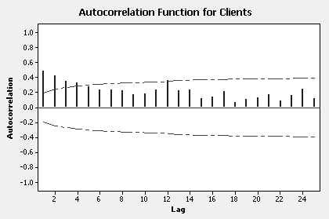

The autocorrelation functions for the differenced series (DiffClients), the seasonally
differenced series (Diff12Clients) and the series with one regular and one seasonal
difference (DiffDiff12Clients) follow.

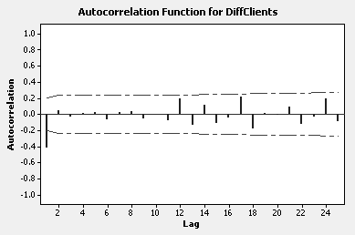

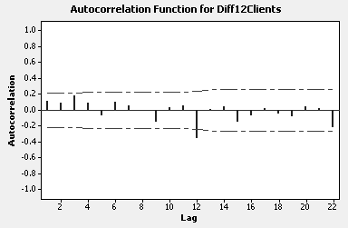

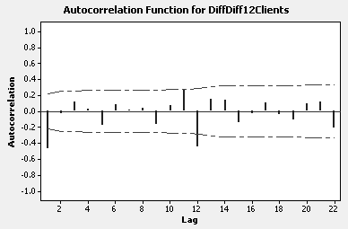

Relative to the autocorrelations for DiffClients and Diff12Clients, the autocorrelations
for DiffDiff12Clients are much more pronounced, indicating one regular difference and
one seasonal difference is too much. The autocorrelations for Diff12Clients are the
cleanest with a significant spike at lag 12 and a slightly smaller spike at lag 24. This
autocorrelation pattern suggests an ARIMA(0,0,0)(0,1,1)₁₂ or an ARIMA(0,0,0)(1,1,0)
model. The former model is the better choice. Summary results and forecasts follow.

Final Estimates of Parameters

Type Coef SE Coef T P
SMA 12 0.4614 0.1055 4.37 0.000

Differencing: 0 regular, 1 seasonal of order 12
Number of observations: Original series 99, after differencing 87

Residuals: SS = 61091.9 (backforecasts excluded)
MS = 710.4 DF = 86
Modified Box-Pierce (Ljung-Box) Chi-Square statistic

Lag 12 24 36 48
Chi-Square 10.9 20.3 30.8 37.4
DF 11 23 35 47
P-Value 0.452 0.623 0.669 0.842

Forecasts from period March 1993

95% Limits
Period Forecast Lower Upper
Apr 1993 123.181 70.931 175.431
May 1993 122.960 70.710 175.210
Jun 1993 140.803 88.553 193.053
Jul 1993 150.944 98.694 203.194
Aug 1993 140.056 87.806 192.306
Sep 1993 134.285 82.035 186.535
Oct 1993 146.517 94.267 198.767
Nov 1993 146.953 94.703 199.203
Dec 1993 126.243 73.993 178.493

CASE 9-4: THE LYDIA E. PINKHAM MEDICINE COMPANY

1. The forecast for 1961 using the AR(2) model is 1290. The revised error
measures are:

MAD = 114 MAPE = 7.1%

2. The results from fitting an ARIMA(1,1,0) model, one step ahead forecasts and
actuals follow.

Final Estimates of Parameters

Type Coef SE Coef T P
AR 1 0.4551 0.1408 3.23 0.002

Differencing: 1 regular difference
Number of observations: Original series 42, after differencing 41
Residuals: SS = 2139107 (backforecasts excluded)
MS = 53478 DF = 40

Modified Box-Pierce (Ljung-Box) Chi-Square statistic

Lag 12 24 36 48
Chi-Square 5.5 22.1 25.3 *
DF 11 23 35 *
P-Value 0.905 0.514 0.885 *

One step ahead forecasts from 1948

Period Actual Forecast Error
1949 1984 1905 79
1950 1787 2018 -231
1951 1689 1697 -8
1952 1866 1644 222
1953 1896 1947 -51
1954 1684 1910 -226
1955 1633 1588 45
1956 1657 1610 47
1957 1569 1668 -99
1958 1390 1529 -139
1959 1397 1309 88
1960 1289 1400 -111

The forecasting equation is ${\hat{Y}}_{t}=1\text{.}\text{455}Y_{t−1}−\text{.}\text{455}Y_{t−2}$.
Comparing the forecasting equation for the ARIMA(1,1,0) model with the forecasting
equation for the AR(2) model given in the case, we see the two equations are very
similar and, consequently, would expect the one step ahead forecasts and forecast
errors to be similar. The error measures for ARIMA(1,1,0) forecasts are

MAD = 112 MAPE = 6.9%

the same as those for the AR(2) model. The choice of one model over the other depends
upon whether one believes the sales series in non-stationary or “nearly” non-stationary.

- This question is intended to stimulate thinking about technological advances in
products (such as the automobile) which could affect sales versus fairly standard
products (such as copper) whose demand may be impacted by technological
advances which require them (such as wiring). There are no right or wrong
answers here--just some that are better than others.

CASE 9-5: CITY OF COLLEGE STATION

1. & 2.
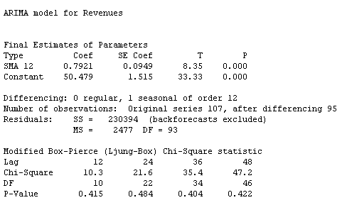

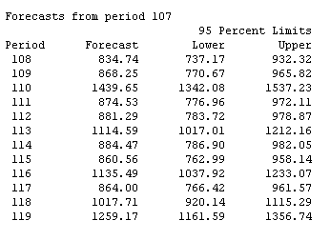

Fitted model: ${\hat{Y}}_{t}=Y_{t−\text{12}}+\text{50}\text{.}\text{479}+ε_{t}−\text{.}\text{792}ε_{t−\text{12}}$

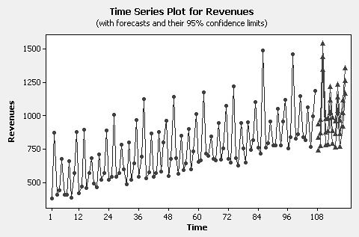

Model fits well and forecasts seem very reasonable.

CASE 9-6: UPS AIR FINANCE DIVISION

1. ARIMA(0,1,0)(0,1,1)₁₂ model for Funding
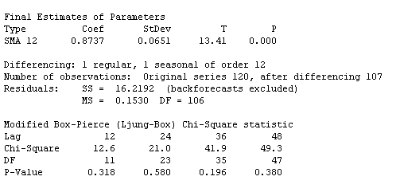
Fitted model: ${\hat{Y}}_{t}=Y_{t−1}+Y_{t−\text{12}}−Y_{t−\text{13}}+ε_{t}−\text{.}\text{874}ε_{t−\text{12}}$
A constant term is not required with a regular and a seasonal difference.

2. The model in part 1 is adequate. The Ljung-Box chi-square statistics show no
significant autocorrelation. The residual autocorrelations and residual plots
below confirm the model is adequate. (There is one large residual in period 49.)

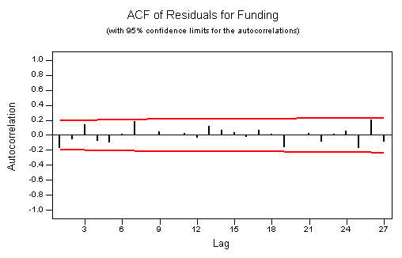
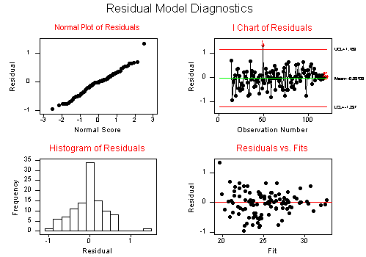

3. The forecasts follow.
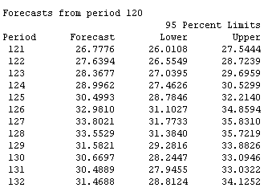

CASE 9-7: AAA WASHINGTON

The results from fitting an ARIMA(0,0,1)(0,1,1)₁₂ model and forecasts follow.
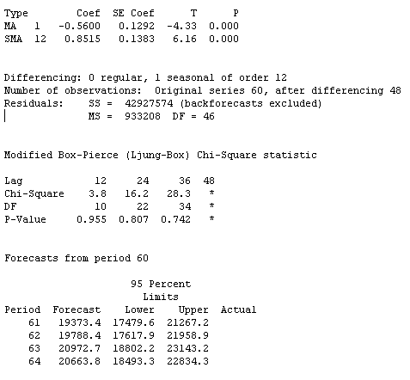

Fitted model: ${\hat{Y}}_{t}=Y_{t−1}+Y_{t−\text{12}}−Y_{t−\text{13}}+ε_{t}+\text{.}\text{56}ε_{t−1}−\text{.}\text{8515}ε_{t−\text{12}}$

The Ljung-Box chi-square statistics show no significant autocorrelation.
The residual autocorrelations are shown below. The residual plots look good.
The model is adequate.

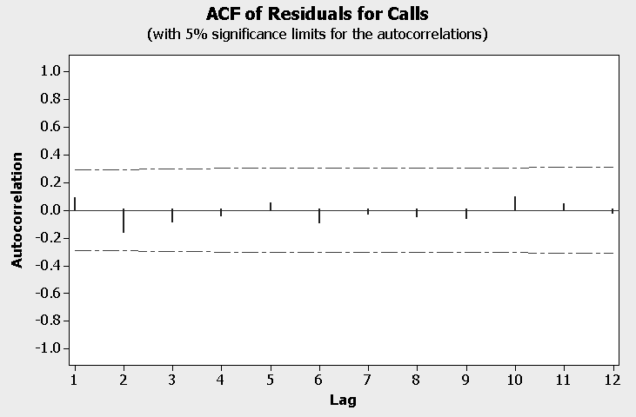

CASE 9-8: WEB RETAILER

1. Results from fitting an ARIMA(0,1,0)(0,0,1)₁₂ model to the Contacts data follows.

Final Estimates of Parameters

Type Coef SE Coef T P
SMA 12 -0.6376 0.3022 -2.11 0.046

Differencing: 1 regular difference
Number of observations: Original series 25, after differencing 24
Residuals: SS = 202359762350 (backforecasts excluded)
MS = 8798250537 DF = 23

Modified Box-Pierce (Ljung-Box) Chi-Square statistic

Lag 12 24 36 48
Chi-Square 10.2 * * *
DF 11 * * *
P-Value 0.513 * * *

This model was suggested by an examination of the plots of the autocorrelation and
partial autocorrelation functions for the original series and the first differenced series.
Another potential model is an ARIMA(1,0,0)(0,0,1)₁₂ model. But if this model is fit to
the data, the estimate of the autoregressive parameter turns out to be very nearly 1,
confirming the choice of the initial ARIMA(0,1,0)(0,0,1)₁₂.

2. The model in part 1 is adequate. The is no residual autocorrelation and the residual plots
that follow look good.

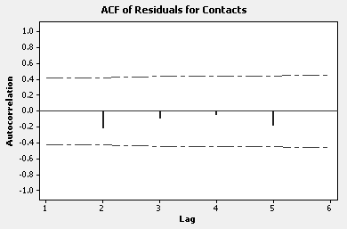

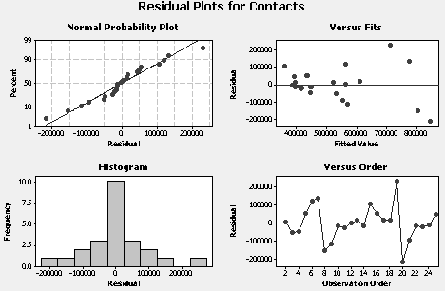

3. Forecasts from period 25

95% Limits
Period Forecast Lower Upper
26 426280 242397 610163
27 492809 232759 752859
28 527275 208780 845770
29 535656 167890 903422
30 545614 134439 956789
31 692161 241741 1142580
32 554640 68131 1041149
33 494570 -25530 1014669
34 484265 -67384 1035914
35 471355 -110135 1052844
36 462995 -146876 1072867
37 491232 -145757 1128222

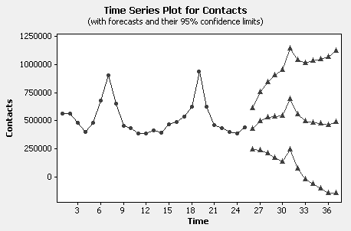

The pattern of the forecasts is reasonable but the forecast of the seasonal peak in
December (recall this series starts in June) is very likely to be much too low. The
actual December peak may be captured by the 95% prediction limits but, because of
the small sample size, these limits are wide. The lower prediction limit is even
negative for some lead times.

4. The sample size in this case is small. With only two years of monthly data, it is
difficult to estimate the seasonality precisely. Although an ARIMA model
does provide some insights into the nature of this series, another modeling approach
may produce more readily acceptable forecasts.

CASE 9-9: SURTIDO COOKIES

1. Results from fitting an ARIMA(0,0,0,)(0,1,1)₁₂ model to Surtido cookie sales follow.

Final Estimates of Parameters

Type Coef SE Coef T P
SMA 12 0.7150 0.1910 3.74 0.001

Differencing: 0 regular, 1 seasonal of order 12
Number of observations: Original series 41, after differencing 29
Residuals: SS = 650837704391 (backforecasts excluded)
MS = 23244203728 DF = 28

Modified Box-Pierce (Ljung-Box) Chi-Square statistic

Lag 12 24 36 48
Chi-Square 7.4 14.2 * *
DF 11 23 * *
P-Value 0.770 0.921 * *

Cookie sales have a strong and quite consistent seasonal component but with
little or no growth. Following the usual pattern of looking at autocorrelations
and partial autocorrelations for the original series and its various differences, the
best patterns for model identification appear to be those for the original series and
the seasonally differenced series. In either case, a seasonal moving average term of
order 12 is included in the model to accommodate seasonality and can be deleted if
non-significant. Fitting an ARIMA(1,0,0)(0,0,1)₁₂ model gives an estimated
autoregressive coefficient of about .9, suggesting perhaps a model with a regular
difference, residual autocorrelations and unattractive forecasts. This line of
inquiry is not useful. The ARIMA model above involving the seasonally
differenced data fits well and, as we shall see, produces reasonable forecasts.

2. As demonstrated by the residual autocorrelation function and the residual plots
below, the ARIMA(0,0,0,)(0,1,1)₁₂ model is adequate.

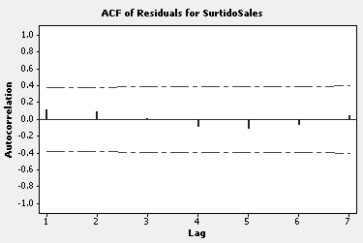

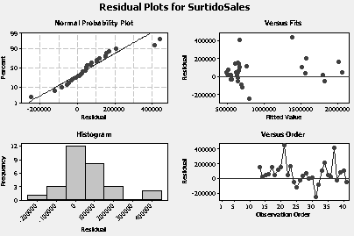

3. The forecasts for the next 12 months follow. Judging from the time series plot,
they seem very reasonable.

Forecasts from period 41

95% Limits
Period Forecast Lower Upper
42 627865 328983 926748
43 721336 422453 1020219
44 658579 359696 957461
45 1533503 1234620 1832386
46 1628889 1330007 1927772
47 2070440 1771557 2369323
48 1805503 1506620 2104385
49 778148 479265 1077031
50 534265 235382 833148
51 525169 226286 824052
52 697168 398285 996051
53 624876 325994 923759

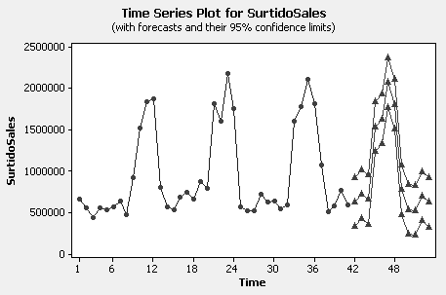

CASE 9-10: SOUTHWEST MEDICAL CENTER

1. Various plots follow. Given these plots, Mary’s initial model seems reasonable.

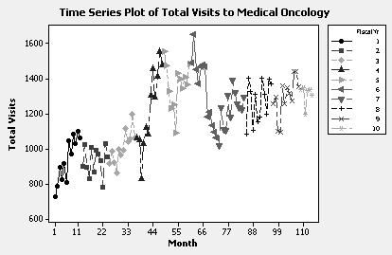

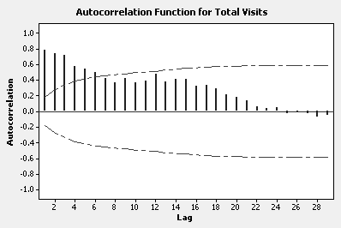

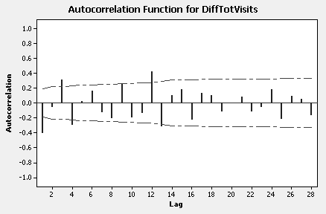

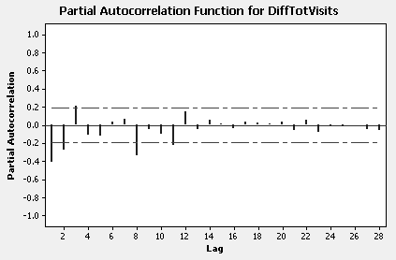
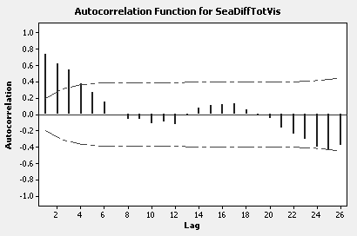

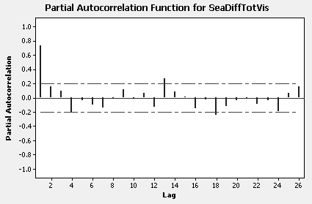

2. Results from fitting an ARIMA(0,1,1)(0,1,1)₁₂ model follow along with a residual
analysis and forecasts for the next 12 months.

Final Estimates of Parameters

Type Coef SE Coef T P
MA 1 0.3568 0.0931 3.83 0.000
SMA 12 0.8646 0.0800 10.80 0.000

Differencing: 1 regular, 1 seasonal of order 12
Number of observations: Original series 114, after differencing 101
Residuals: SS = 988551 (backforecasts excluded)
MS = 9985 DF = 99

Modified Box-Pierce (Ljung-Box) Chi-Square statistic

Lag 12 24 36 48
Chi-Square 21.2 53.0 72.9 88.1
DF 10 22 34 46
P-Value 0.020 0.000 0.000 0.000

Forecasts from period 114

95% Limits
Period Forecast Lower Upper
115 1419.59 1223.70 1615.49
116 1438.07 1205.16 1670.99
117 1386.09 1121.28 1650.90
118 1376.53 1083.27 1669.79
119 1459.48 1140.30 1778.66
120 1431.27 1088.12 1774.41
121 1365.43 999.88 1730.98
122 1456.48 1069.83 1843.14
123 1324.46 917.79 1731.12
124 1303.44 877.70 1729.17
125 1442.69 998.71 1886.68
126 1350.23 888.71 1811.74

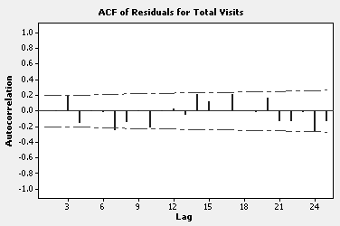

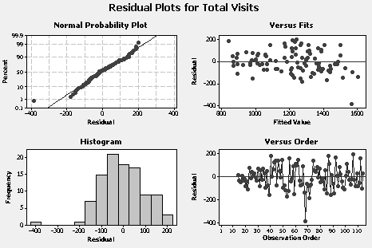

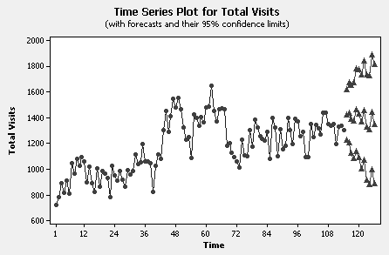

Collectively, the residual autocorrelations are larger than they would be for random
errors; however, they suggest no obvious additional terms to add to the ARIMA model.
Apart from the large residual at month 68, the residual plots look good. The forecasts
seem reasonable but the 95% prediction limits are fairly wide.

3. Total visits for fiscal years 4, 5 and 6 seem somewhat removed from the rest of the data.
Total visit for these fiscal years are, as a group, somewhat larger than the remaining
observations. Did something unusual happen during these years? Was total visits
defined differently? This particular feature makes modeling difficult.

CHAPTER 10

Judgmental Forecasting and Forecast Adjustments

ANSWERS TO PROBLEMS AND CASES

1. The Delphi method can be used in any forecasting situation where there is little or no
historical data and there is expert opinion (experience) available. Two examples might
be:

- First year sales for a new product
- Full capacity employment at a new plant

Potential difficulties associated with the Delphi method include:

- Assembling the “right” group of experts.
- Overcoming individual biases or agendas
- Not being able to arrange timely feedback

2. a. Month Averaged Forecast
1 4924.5
2 5976.0
3 6769.0
4 4708.0
5 4964.0
6 6102.0
7 8212.5
8 6178.5
9 4806.5
10 4228.5

b. Month WtAvg Forecast
1 4721.4
2 5956.8
3 6731.2
4 4601.2
5 4991.6
6 6385.2
7 8362.2
8 6320.4
9 4596.8
10 4474.2

c. Winters’ forecasts MAPE = 9.8%, Regression forecasts MAPE = 7.7%
d. Averaged forecasts MAPE = 7.4%, Weighted averaged forecasts MAPE = 8.8%.
So based on MAPE, forecasts created by taking simple average of Winters’
forecasts and Regression forecasts are preferred.

CASE 10-1: GOLDEN GARDENS RESTAURANT

1. & 2. Sue and Bill have tackled a very tough business project: designing a restaurant
that will succeed. Restaurants seem to come and go on a regular basis so their
planning efforts prior to opening are important.

They have already tried focus groups and have some ideas to add to their own.
Since they have a number of "expert" friends, some way must be found to use this
expertise. The Delphi method suggests itself as a way to utilize their friends'
knowledge. A written description of the project along with the question of proper
motif could be supplied to each of their friends, along with a request to design the
restaurant. These descriptions would then be mailed back to each participant with
a request to re-design the business based on all the written replies. This process
could be continued until changes are no longer generated.

An optional step would then be to bring the participants together for a discussion.
This expert focus group could argue their cases and respond to Sue and Bill's
objections or insights. At the end of this process Sue and Bill would probably have
a better idea of how a successful restaurant would look and could begin their project
with more confidence. Also, financial backers would probably be more enthusiastic
after reviewing the extensive planning that Sue and Bill have undertaken prior to
opening their business.

CASE 10-2: ALOMEGA FOOD STORES

1. The naïve forecasting model is not very accurate. The MSE equals
8,648,047,253.

2. The MSE for the multiple regression model (from the regression output)
equals 2,097,765,646 which is quite a bit less than the naïve model.

3. If the naïve approach had been more accurate, combining methods would have
been worth a try.

4. If Julie did combine forecasts, she should use a weighted average that definitely
favored the multiple regression model.

CASE 10-3: THE LYDIA E. PINKHAM MEDICINE COMPANY REVISITED

- These articles are more abundant than many realize. More "popular” journals,
particularly financial markets titles such as Technical Analysis of Stocks &
Commodities, Financial Analysts Journal, and Futures present several articles.
In addition, the proceedings from the neural network conferences (published by
IEEE) will usually have some business applications. Finally, this approach is
beginning to appear in more scholarly journals such as Management Science and
Decision Sciences.

- The interested student with access to a neural network simulator should enjoy
this assignment. In addition to the "backpropagation" approach, students might
try radial basis functions and least mean squares if they are available.

3. Model specification is as much an art as it is a science. for example, look at Case
9-4 where the choice between ARIMA(1,1,0) and AR(2) models is not clearcut. Neural
networks, however, do not require the analyst to specify the form of the
model -- they have been called "model free" function approximators (see Bart
Kosko, Neural Networks and Fuzzy Systems: A Dynamical Systems Approach
to Machine Intelligence, Prentice-Hall, 1992, for example).

CHAPTER 11

Managing the Forecasting Process

ANSWERS TO PROBLEMS AND CASES

1. a. One response: Forecasts may not be right, but they improve the odds of being
close to right. More importantly, if there are no agreed upon set of forecasts to
drive planning, then different groups may develop own procedures to guide
planning with potential chaos as the result.

b. One response: Analogy—If you think education is expensive, try ignorance.
Having a good set of forecasts is like walking while looking ahead instead of at
your shoes. Planning without forecasts will lead to inefficient operations, sub
optimal returns on investment, poor customer service, and so forth.

c. One response: Good forecasts require not only good quantitative skills, they also
require an in-depth understanding of the business or, more generally, the
forecasting environment and, ultimately, good communication skills to sell
forecasts to management.

CASE 11-1: BOUNDARY ELECTRONICS

1. This case invites students to think about how to use some of the forecasting techniques
discussed in Chapter 11. Guy Preston is trying to get his managers to think about the
long-range position of the company, as opposed to the short range thinking that most
managers are involved in on a daily basis. The case might generate a class discussion
about the tendency of managers to shorten their planning horizons too much in the
daily press of business.

Guy has asked his managers to write scenarios for the future: a worst case, a status quo,
and a most likely scenario. His next task might be to discuss each of these three
possibilities, and to discuss any differences of opinion that might emerge. A second
round of written scenarios by each participant could then follow this.

2. The instructor should point out that the purpose of Guy's retreat is to expand the
planning horizon of his managers. He should be prepared to continue this effort after
the first round of written scenarios: it is quite possible that his team is still caught
up in the affairs of the day and is not really engaged in long range thinking. He should
encourage expanded thinking after the discussion phase and try during the day to continue
such thinking.

3. There are two possible benefits from Guy's retreat. First, he may gain valuable insights
into the company's future to use in his own long range thinking. Second, and
probably more important, his managers may come away with an increased
awareness of the importance of expanding their planning horizons. If this is true,
the company will probably be in a better position to face the future.

CASE 11-2: BUSBY ASSOCIATES

1. Since Holt’s linear smoothing incorporates simple exponential smoothing as a special
case (β = 0), would expect Holt’s procedure to fit and forecast better here.
Therefore, there is no reason to consider a combination of forecasts. Combining
forecasts is best considered when the sets of forecasts are produced by different
procedures.

2. Jill should definitely update her historical data as new data points arrive. Since she
is using a computer program to do the forecasting, there would be very little effort
involved in this process. Why not update and re-run every quarter for a while?

3. After the results for a few additional quarters (say 4) become available, the analysis
can be re-done to see if the current model is still viable. Model parameters can be
re-estimated after each new observation if appropriate computer software is available.

4. Box-Jenkins ARIMA methodology is not well suited for small sample sizes and
can be difficult to explain to a non-statistician.

This case illustrates the practical problems that are typically encountered when
attempting to forecast a time series in a business setting. Among the problems Jill encounters are:
- She chooses to forecast a national variable for which data values are available
in the Survey of Current Business. Will this variable correlate well with the
actual Y value of interest (her firm's export sales)?
- Her initial sample size is only 13.
- When she attempts to gather more data, she finds that the series underwent a definition change during the recent past, resulting in inconsistent data. She must shift her focus to another surrogate variable.
- Her data plot indicates a bump in the data and she decides a more
consistent series would result if she dropped the first few data points.

A real life-forecasting project could very likely involve difficulties such as those
Jill encountered in this case, or perhaps even more. For this reason this case is a "good
read" for forecasting students as they finish their studies since it shows that judgment
and skill must be involved in the forecasting effort: forecasting problems are not usually

as clean and straightforward as textbook problems.

CASE 11-3: CONSUMER CREDIT COUNSELING

Students should summarize the results of the analyses of these data in the cases at the
ends of chapters 4 (smoothing), 5 (decomposition), 6 (simple linear regression), 8 (regression
with time series data) and 9 (Box-Jenkins methods). Fits, residual analyses, and forecasts can be compared. Regardless of the method, there is a fair amount of unexplained variation in the
number of new clients. This may be a situation where combining forecasts makes sense.

CASE 11-4: MR. TUX

We collected the data from the Mr. Tux rental shop so that real data could be used at the end of each chapter instead of contrived data. We didn't know what would happen when we tried to forecast this variable, but we think it turned out well because no one method was superior.
The case in Chapter 11 summarizes the different ways John used to forecast his monthly sales, and asks students to comment on his efforts. We think a key point is that a lot of real data sets do not lend themselves to accurate forecasting, and that continually trying different methods is required. For the Mr. Tux data, there are fairly simple seasonal models (see the cases in Chapters
8 and 9) that represent the data well and provide reasonable forecasts.
What advice should we give to John Mosby for the future? Some suggestions to offer might include:

- Update the data set as future monthly values become available and re-run the
most promising analyses to see if the current forecasting model is still viable.

- Consider combining forecasts from two different methods.

- Try to develop a useful relationship between monthly sales and regional
economic variables. Perhaps the area unemployment rate or an economic activity index would correlate well with John's sales. Perhaps some demographic
variables would correlate well. If several variables were collected over the
months of John's sales data, a good regression equation might result.
This would allow John to understand how is sales are tied to the local
environment.

CASE 11-5: ALOMEGA FOOD STORES

- Julie has to choose between two different methods of forecasting her company’s
monthly sales. Students should review the results of these two efforts and decide
which offers the better choice. We find that class presentations by student teams
are valuable as they move the analysis beyond the computer results to simulate
implementing these results in a “real” situation.

- Having students, either individually or in teams, prepare a memo to Julie outlining
their analysis and choice of forecasting method is an alternative to class
presentations. Again, the results of this case do not point to a “right” answer, but
rather to the necessity of choosing a forecasting method and justifying its use. Non-
quantitative considerations should come into play: the fact that Julie is the first
female president of Alomega, that she jumped over several qualified candidates for
the job, and that one of her subordinates (Jackson Tilson) seems to be unimpressed
with both her and any computer analysis.

3. Other forecasting methods are certainly possible in this case. An assignment
beyond a consideration of choosing between decomposition and multiple
regression would be to find a superior forecasting method using any available
software. Again, the qualitative considerations should be considered, including the
necessity of balancing the complexity and accuracy of a forecasting method with its
acceptance and use by the management team.

4. Only if she finds two good methods.

CASE 11-6: SOUTHWEST MEDICAL CENTER

Students should summarize the results of Mary’s forecasting efforts describing the fits,
residual analyses and forecasts. Moreover, they should point out the apparent difficulty in
finding an adequate model for Mary’s total visits series. If Mary’s data is accurate—there is no
reason for the apparent inconsistency in her time series—then it would probably be wise to
collect another year or so of data and attempt to model the entire data set or, perhaps, just the data following fiscal year 6. In the interim, she may have to settle for the forecasts from the
best ARIMA model developed in Case 9-10.

